MINISTRY REPORT FOR JULY 2008
THE CROSSROADS, CAMBODIA

INTRODUCTION
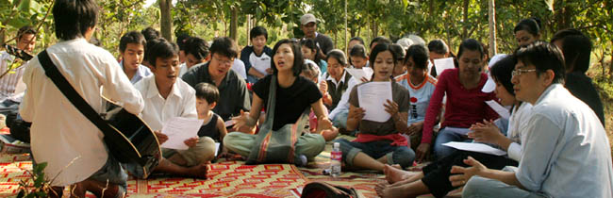
The Crossroads seeks to bring Cambodian university students into the Kingdom of God. A Christian community has been established through providing dormitory for men and women since year 2000. A church was founded soon thereafter, with is average attendance at the church total about 52 people weekly to date. By the grace of God, the Crossroads perseveres to penetrate into this broken nation to win over the lost soul by soul.
The Crossroads will be setting aside a group of 4-5 university students to plant another church in Phnom Penh in September 2008. This is church plant number 5. Praise the Lord. Please pray for its preparation on essential groundwork. Your prayer and intercession will be of great importance to support the church plant that it will bear fruit abundantly.

Re-strategizing the crossroads for growth
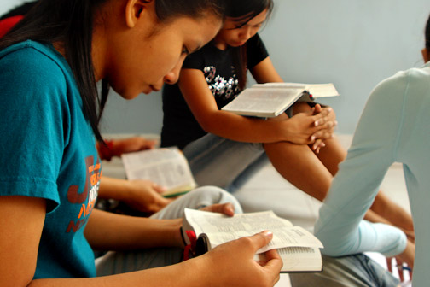
With the inflation surging in almost every part of the world, ministry in Phnom Penh is also severely tested financially. Many Christian groups have already been forced to move away from the city due to increased in rents. Yet, the city must not be left unattended spiritually and strategically. It is pivotal to reclaim this land for the purpose of bringing the gospel to the whole country. The Crossroads, therefore, has committed to rebuild and restore this nation by raising, equipping and nurturing university students to be future leaders of Cambodia.
Over the next few months, the Crossroads will also be commissioning out small groups to plant churches using ‘house church model’ within the city. With financial persecution arises, the Lord also providing a way out to curb financial constraint in ministry. This house church will be ‘cheaper’ and will be able to house more university students. Indeed, the way of the Lord is higher than our way, and his thought is higher than our thought. We pray for the Lord’s guidance and protection as we desire for 3 houses by end 2008.

salvation to the household
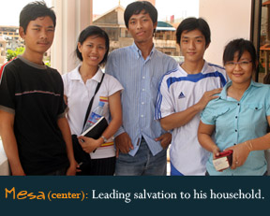
Mesa came to know the Lord through soccer ministry. In mingling with students from the Crossroads and it soccer ministry, Mesa was attracted by Khmer Christian lifestyle. His heart began to open up to the gospel and his journey with the Lord took off. He studied the word of God seriously and attended meetings at the Crossroads regularly.
Everyone witnessed his faith growing daily as he would also testify on the greatness and goodness of the Lord regularly. Mesa confessed on his powerlessness in life. He admitted his unresolved confrontation with physical and spiritual death that he could not change the course of its direction.
Soon, Mesa sister, Sokporn began coming to the church weekly. Being eldest at home thus being responsible for her sibling, Sokporn has always been worried about Mesa’s future undertaking. With Mesa’s life being transformed, Sokporn has been very interested by the power of the truth and His love. Eventually, Sokporn was convinced of her need for salvation and on Sunday worship, she stood up to entrust her life to the Lord. Please pray for this new faith to grow into maturity in Christ. Please also pray for their brother, Rina, and their aging parents in the province.

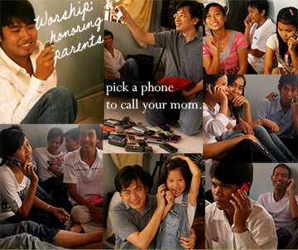
honor your parents
Honoring parents is fundamental in Khmer’s culture. Similar to the bible, those who honor their parents will have long life. However, such honorable practice has been so diluted in modern days. Students living away from their parents are also further handicapped by their tradition that they do not make expression of their feeling to their parents openly. Such practice is only done when the children hold rites after their parents’ death.
During the last Mother’s Day, we collected all students’ cell-phone and after all preparations, we have the church called their mother individually to express their love and thanksgiving for them. We praise the Lord for he made restoration of relationship. We pray that through such practice we will foster more intimate relationship between parents and their children, thus allow the Holy Spirit to work through such relationship.

veoun and spiritual accountability group
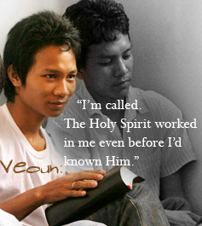
Veoun used to live with 9 other friends in a very small room. They shared the rental and monthly utilities and lived shabbily. He came to the Crossroads in February 2008. Though he had many questions from within, he faithfully studied the bible with other new students at the Crossroads.
At school one day, the teacher wanted to know if there are Christian in the classroom. He was caught off guard but ironically, he had his hand raised up. He felt weird but remained silent. A few days later, the bible class(at Crossroads) studied on Jesus and Nicodemus. He was convicted that the Holy Spirit was working within him and he testified to all on how amazing the work of God is. He also professed his faith and committed to walk with the Lord.
Veoun and a few students meet weekly as spiritual accountable group. They help one another to ‘put off’ their old self, and to ‘put on’. Indeed, no one who lives in him keeps on sinning; and no one who is born of God continue to sin, because God’s seed remains in him. The group of students is a blessing to live with, and they are certainly a great vessel for the Lord’s use.

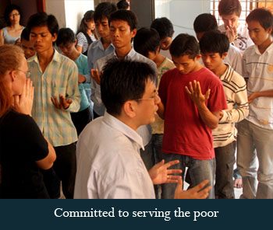
ministry to the ‘poor’
Preaching Goodnews to the poor is never easy unless we are ready to pour out without expecting any return. Such is the demand for commitment to minister to the poor that we are to be consistent with the love of God for them. The Crossroads understood the calling and is preparing itself for such ministry.
We thank the Lord for giving us a willing heart to begin, and for us who are inadequate, we are praying that the Lord will enable us to put our trust in Him. We praise the Lord for the group of willing heart to commit to such a demanding ministry. We pray that the Lord will use Him mightily for His kingdom work.

family news
The Lord’s leading for the Oois is increasingly challenging in an ever changing Phnom Penh city. This is their 8th year in Cambodia. We came just as a couple after married, but now, Joey and Rohaam is 6 yrs and 3 yrs respectively.

We are now preparing the kids for home-schooling. We have never contemplated this journey but the Lord has in His own way and time provided us with some affirmation and even gracious provision on precious resources. This is certainly another step of faith for us, and we trust that the Lord will make good for His use. Please continue to pray for the kids that they will grow in stature and wisdom, and in favor with God and men.
Please also pray for David and Moonjung’s leadership at the Crossroads. Living with the students for the last 8 years has developed our marriage and family life into something very unusual, yet very enriching in experience and spiritual walk. Please pray for us that our marriage will continue to grow in Him; that we will have wisdom and discernment to nurture our children and spiritual children(38 students); and that our family will always be a channel of blessing to people around us wherever we shall be.

conclusions
The uncertainty ahead is real. Thus, life goes on with much struggle and hardship. However, one thing is certain – that the life of these students have embraced God’s mission. As we thank God for His faithful provision for our needs, we turn our thoughts to the promised return of Jesus Christ. In patient expectation, we live for Him and look for the day when He will gather His glorious harvest home. And we shall be like Him, for we shall see Him as He is. This is the reason the Crossroads lives.

Many blessings,
David Ooi.

