introductions
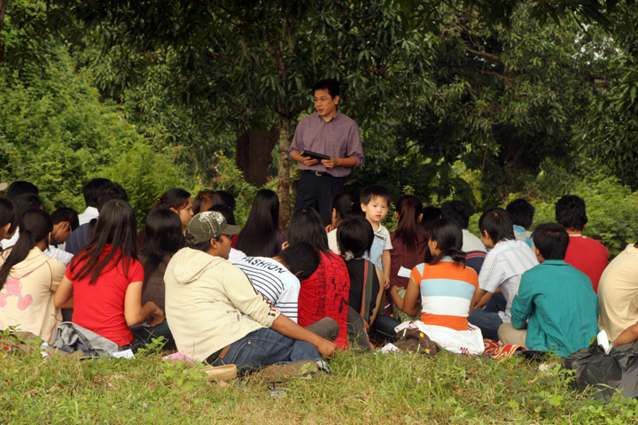
The Crossroads(est. since 2000), pressed on to pursue its vision – Rebuilding and Restoring Cambodia. The discipleship based ministry, which aims at character building thus developing a Christ centered disciples, is at Phnom Penh, Cambodia. It houses selected university students who comes from various provinces to pursue their tertiary education at Phnom Penh. While going to school in the daytime, the students would devote themselves to the teaching of His words and to the fellowship, to the breaking of the bread and to prayer in the evening.
The Lord has blessed Crossroads abundantly despite the recent time of uncertainty. The number has continued to grow consistently and increasingly, and so is their faith. These students, who has come from various backgrounds have suffered from bondages and brokenness in their growing up process, are being healed, restored and empowered by His words.
At year 2007, and after planting 5 churches in the provinces, the Crossroads leadership re-focused to mainly church planting in Phnom Penh. This is necessary due to the work of God through political changes and socio-economy factors. By end 2008, the Lord had caused a church to be planted in Phnom Penh – The Pillars. In March 2009, another church was planted. We look forward to plant more house churches in Phnom Penh and we invite you to join us in unity to develop Christ-centered disciples amongst University students in Phnom Penh. By year 2011, there will be 180,000 students coming to Phnom Penh city for further education each year. We pray that the Lord will use the Crossroads to do something that is hard to believe(Hab.1:5).

12 students graduated last year
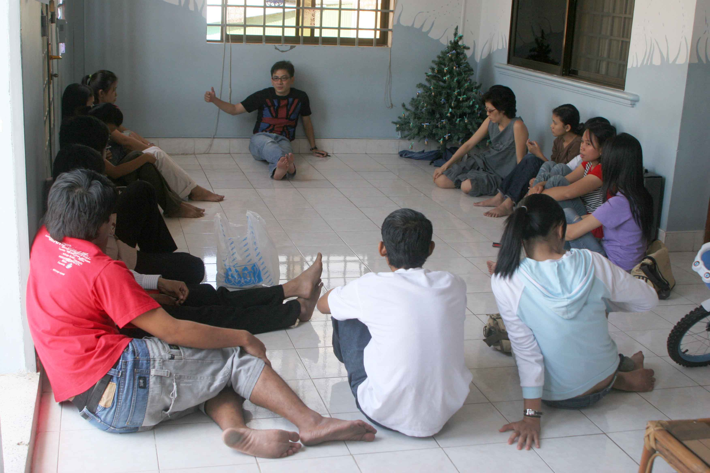
Last year, we have had 12 students graduated from university. They are all believers and have been discipled. Though life at work is not the same as at school, these graduates are being guided that their faith will continue to grow daily.
One of the praise is that all the graduates have found a job, something which is scarce in Cambodia. Some of these graduating students have a clear idea about what’s next – where they will be going and what they will be doing. Others still have much to answer – Does the Lord want me to serve him in the marketplace? In the pastorate? Ministry? But one thing is definite – all our students have a ‘ministry mind set’ and know that the Lord will use them to impact people’s lives wherever they are.

The pillars(d.o.b. 16th oct 2008)
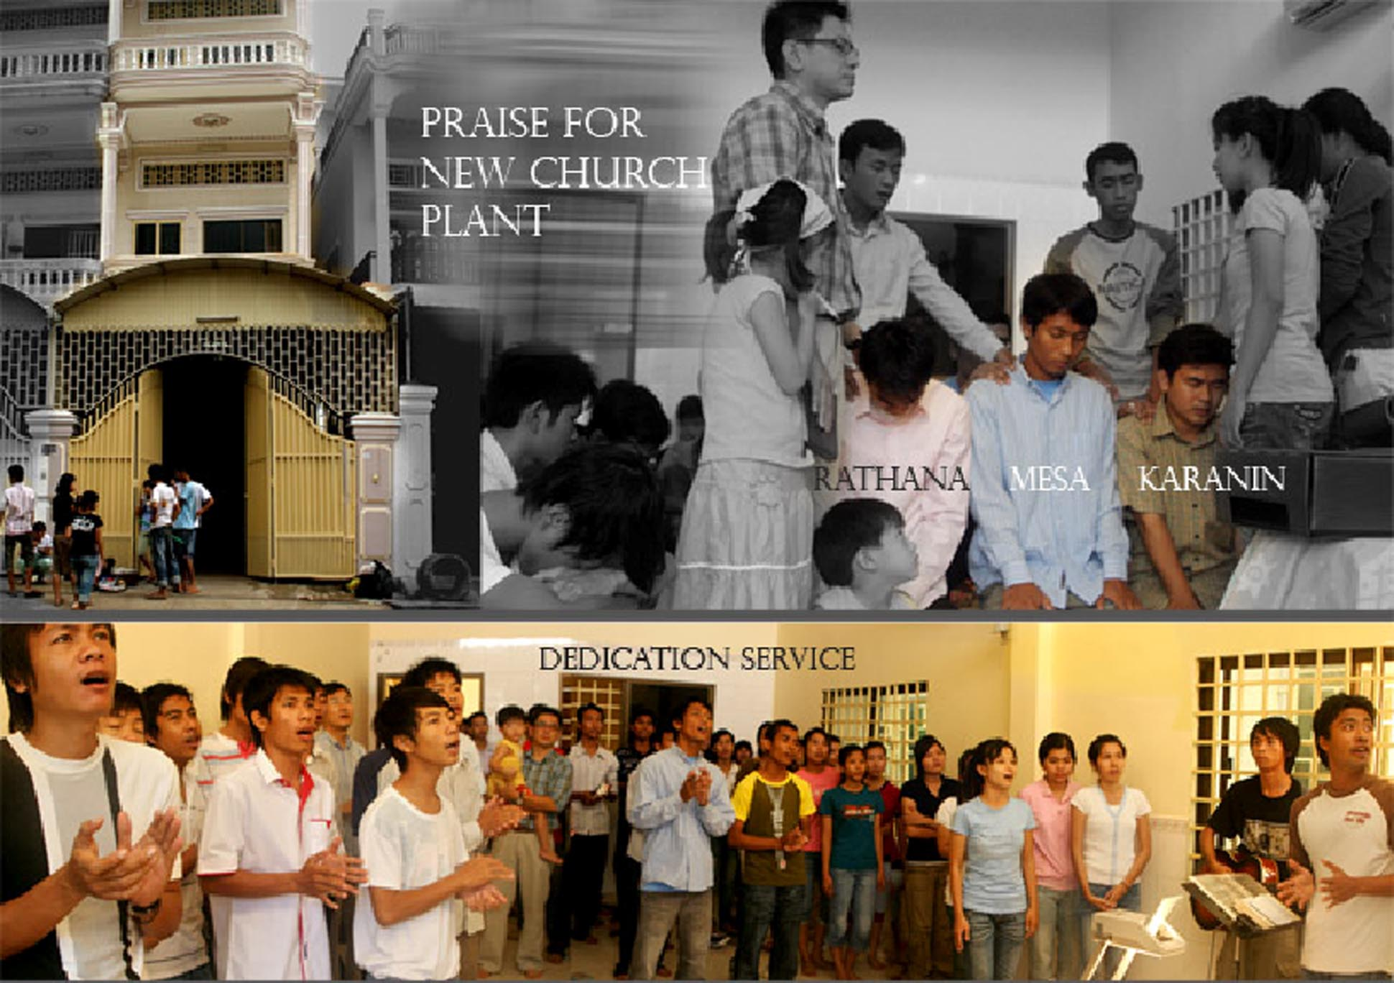
The Great Commission is deeply embedded at the Crossroads. Naturally, it has been the desire of the church to make disciple of the nations through church planting especially within the city. Ever since July 2007, the leadership has been praying and seeking the Lord’s guidance. In early 2008, the prayer was answered. As the leadership was ready, the Lord also made His provision available. Rathana, Karanin and Mesa were commissioned by the Crossroads to fulfill His Great Commission.
The Pillars is located at one of the largest and fastest growing university in the city which majors in Accounting. There are now 8 students residing at the Pillars. The way it started was humbling and we trust that in years to come, the Pillars will grow like a mustard seed. We await and watch mighty things the Lord will do through the Pillars. We are praying for mission teams and short-termers to come alongside the Pillars to reach out to many Cambodian university students who are still oppressed and imprisoned by the power of darkness.
Please pray for these leaders, as well as the Pillars’ ministry as a while. The church would need much protection, much more grace and mercy. May they strive for His holiness thus reflecting His glory in Phnom Penh, more specifically amongst university students within its vicinity.

The crossroads enterprise
For year 2009, the Lord has been leading the Crossroads to abundant gospel sowing – if we sow more generously, we will also reap generously. This will be culturally challenging for most Cambodian due to their passive nature. But still, the Crossroads is committed onto the Great Commission(Matt 28.18-20) as we trust the Lord(Mk. 4:26-29).
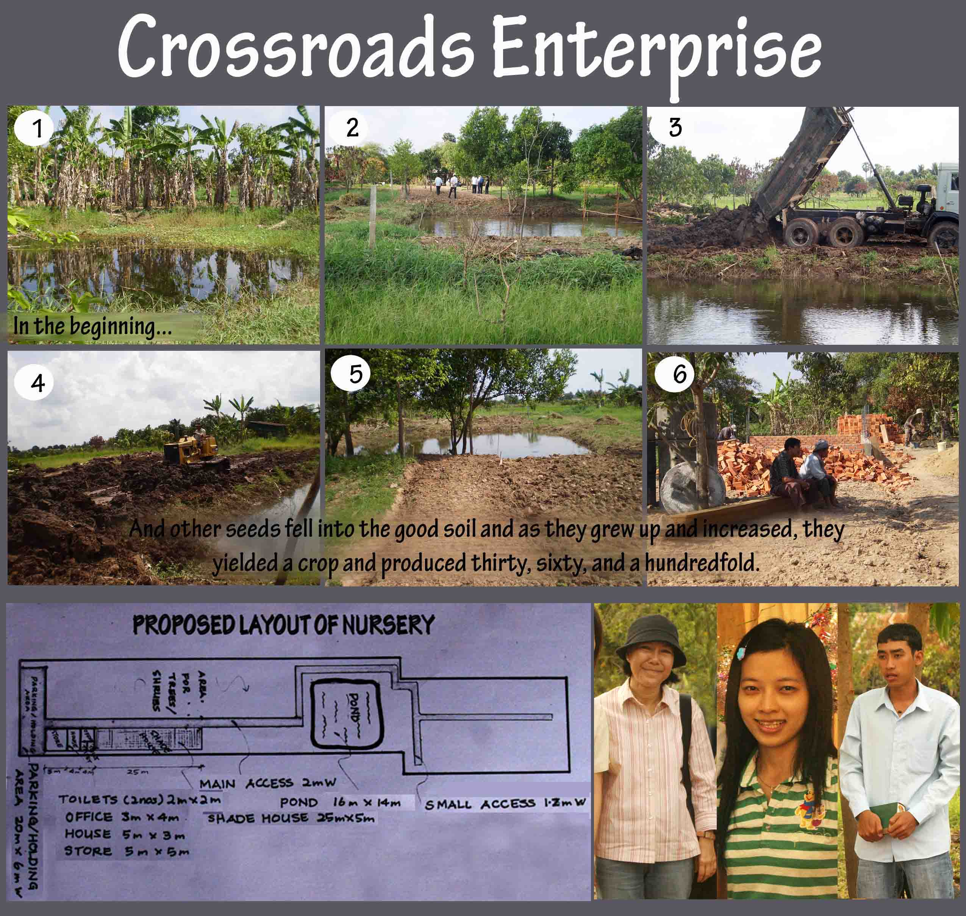
Last year, the Crossroads had celebrated graduation of 11 university students. Amazingly, they have all been blessed with jobs and are in the market place now. Naturally, the Crossroads is venturing into new ministry – Reaching out to graduates and young working adult. Please pray as we will await the seed to sprout thus to harvest with joy.
Indeed, as to how the seed spouted, we know not(Mk.4:27b). Not knowing how, but the Crossroads has ventured into Crossroads Enterprise. Crossroads Enterprise is about the gospel being preached and demonstrated in a real tangible and practical way through business enterprises, using assets and resources owned by the students. The goal of this enterprise is to generate income for the purpose of House Churches Planting in the city which the Crossroads has been committed to.
To begin, the Crossroads has started a Nursery & Landscaping business. In His time, the Lord has sent us expert in agriculture and horticulture to enable His Kingdom building. One recent graduate, Bora, has a plot of land just outskirt of the city. He was envisioned, equipped and trained to utilize his land for enterprise purpose. Please pray that the Lord will bless this enterprise that through His gracious blessing, the Crossroads will be a blessing to others.

Micro-loans
Karanin, had graduated and was sent to be a high school teacher in Pursat. While there, he partnered with the Crossroads to plant a house church. He has now been transferred to Phnom Penh to teach, a profession in Cambodia where a Christian would be persecuted always. His refusal to accept bribe and perseverance of being faithfulness to God makes Karanin a cornerstone of the Crossroads. He is now also part of the Pillars leadership team, a church plant of the Crossroads.
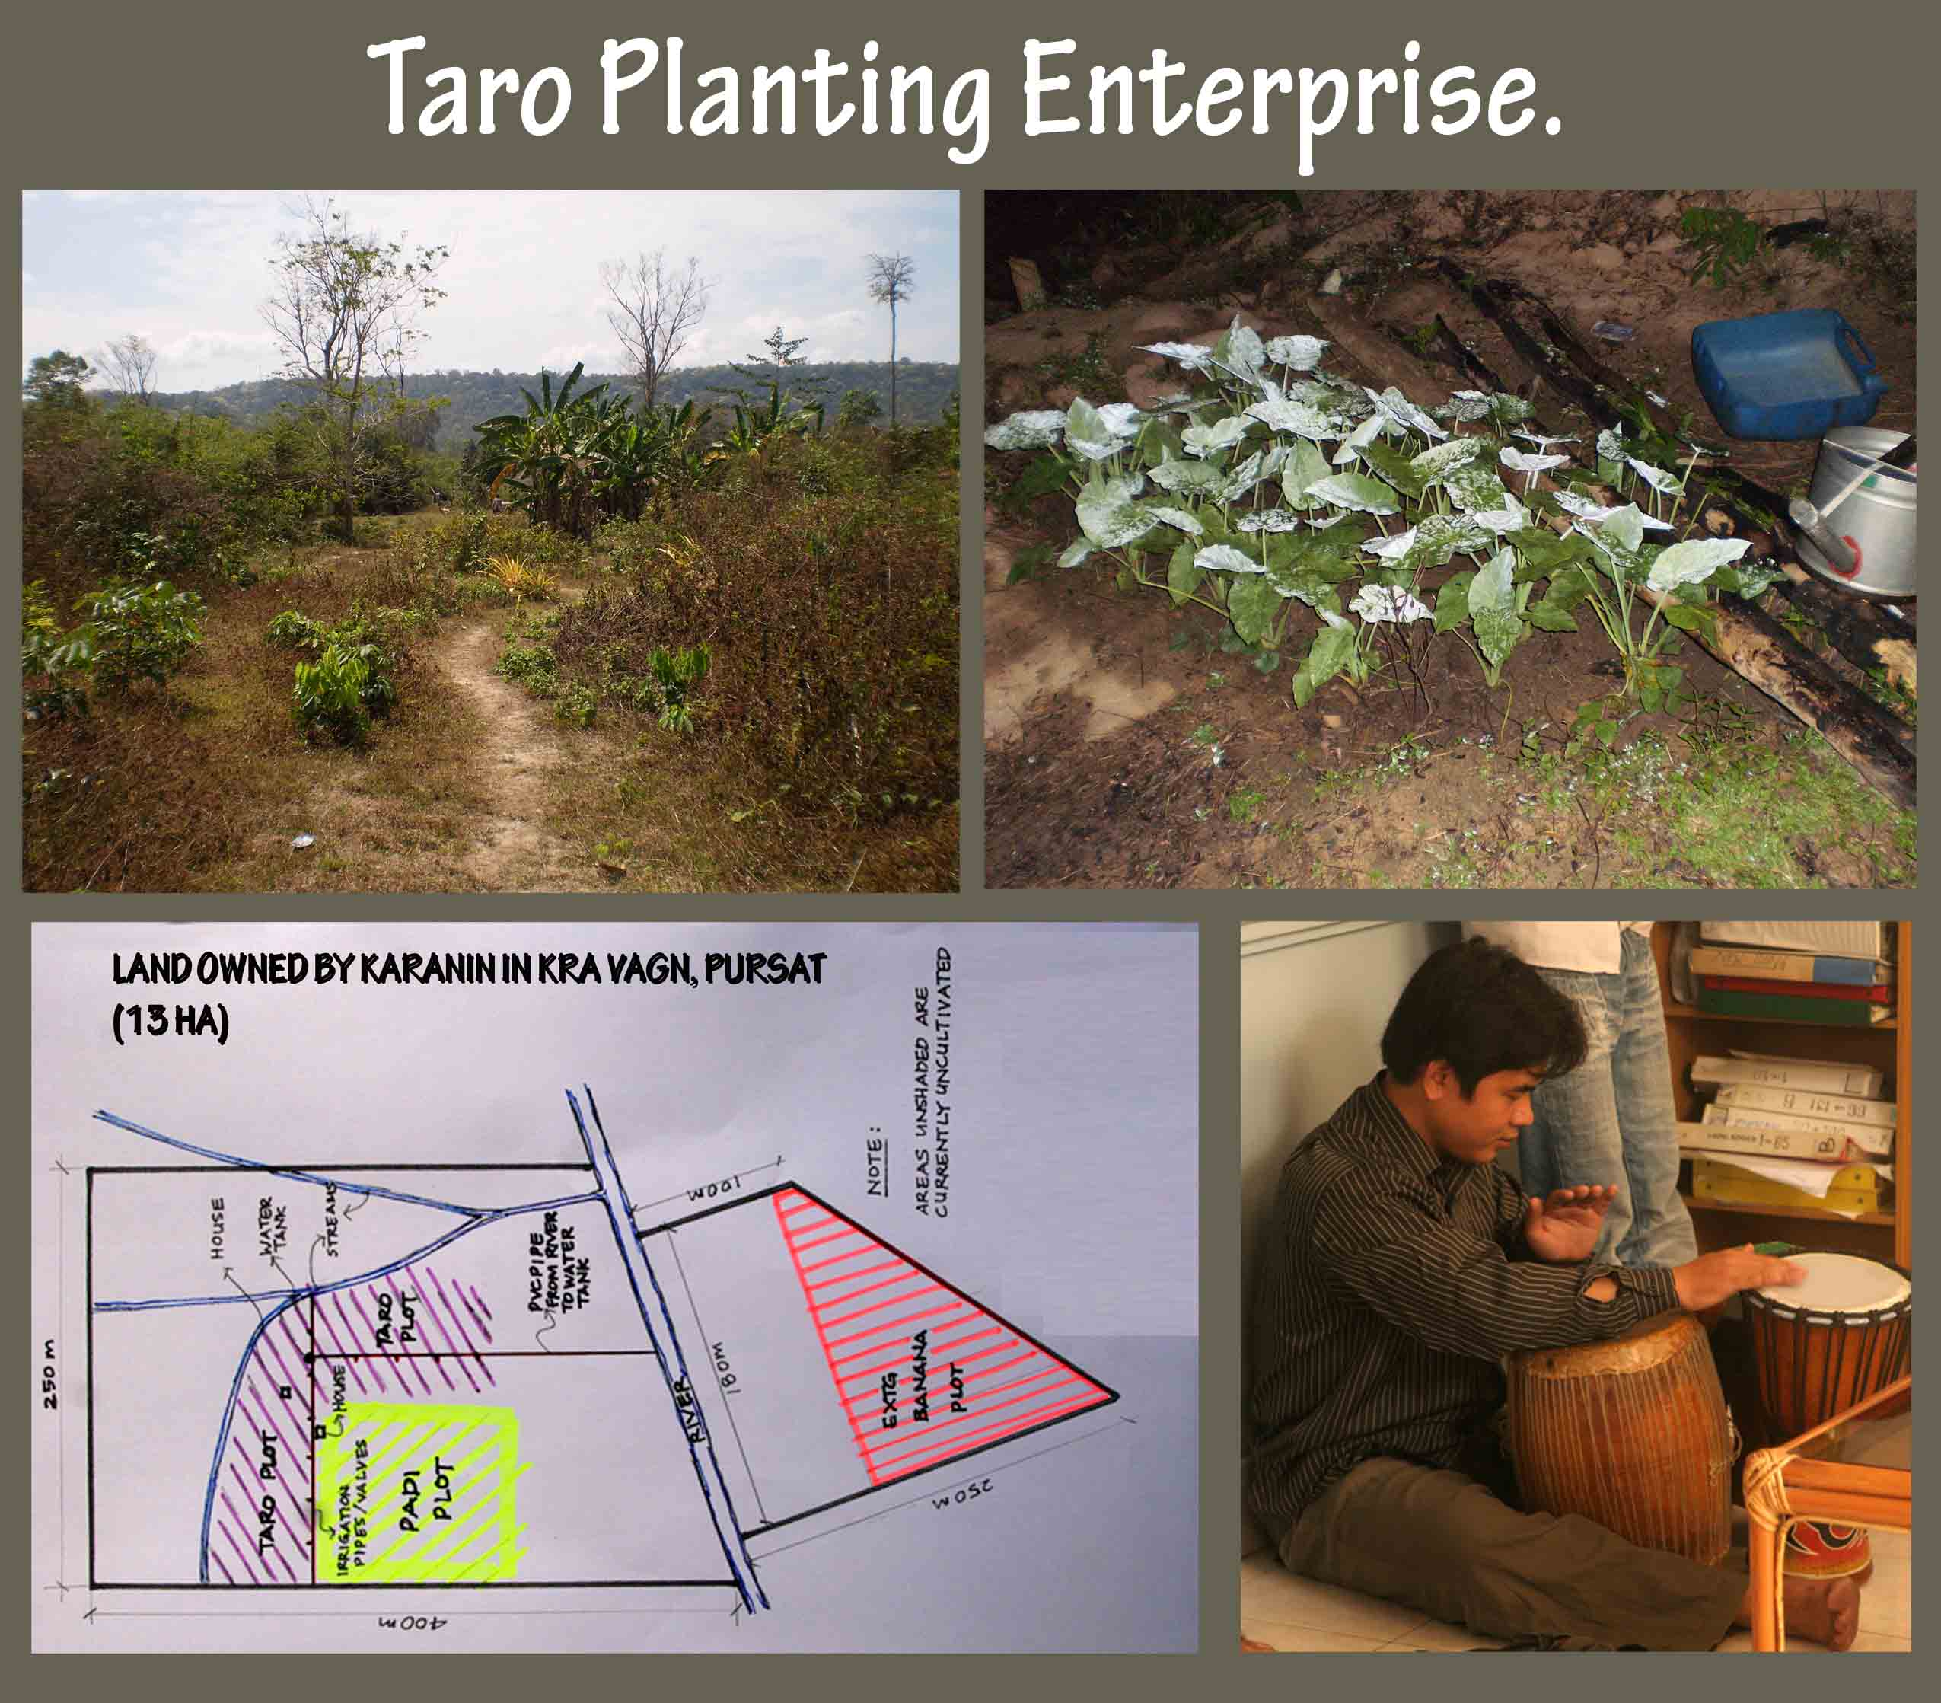
Like many others, Karanin embarked upon a teaching profession believing that the profession would be a ‘never dried up well’. Such is a Christian struggle in reality. God has granted us wisdom, an enlightenment on how to fill the ‘never dried up well’ with living water thus always demonstrating His grace to people around. With a micro loan, and consultation from expert, Karanin is now planting Taro which will generate income for his livelihood. His desire is to be a witness to Him everywhere he goes, no matter what season it is. We pray that His handiwork will make Karanin’s desire come true. We wait to reap in Aug/Sept 2009. What a hope in Jesus.

Nikra – Being in step with the spirit
Nikra’s aunt was a sorcerer. Since her young age, the spirit her aunt had been a slave to had wanted to pass the baton to Nikra. This explained how Nikra would not need to go to any doctor or medication whenever she was sick. Her simple remedy was to merely step into the building where the spirit was based and she would be healed immediately.
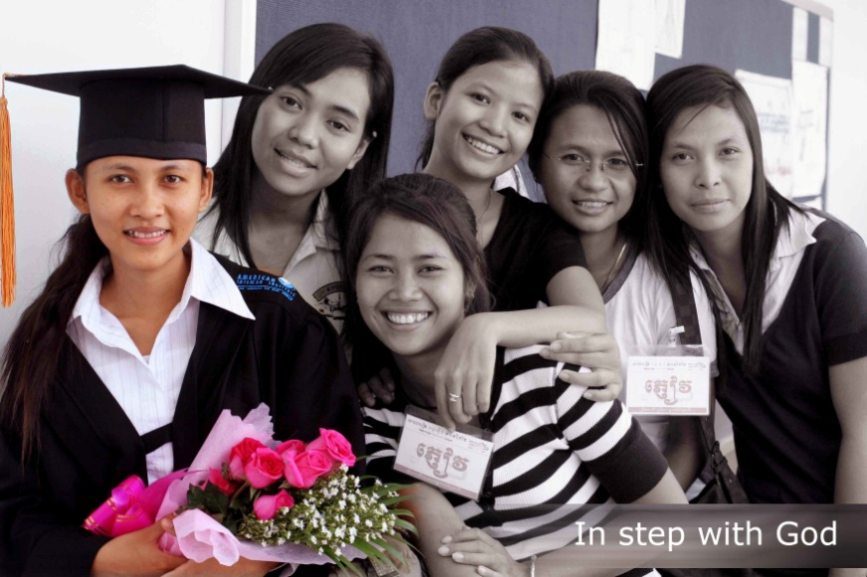
But God would not be silenced. God was very faithful to prosper Nikra. He has been very gracious and consistent in manifesting Himself to Nikra, which Nikra had secretly acknowledged. Nikra soon felt and understood that she was imprisoned by the spirit and needed to be set free.
The day of confrontation finally had come. Nikra was more prepared to plead with the sorcerer aunt to let her go. The truth is that Nikra knew and that even her aunt would agree that Nikra needed salvation(spirit does know Jesus after all). She knew that she had no other option other to call on the name of the Lord. One morning, Nikra came with much tremble. In her dream, she was punished by the spirit for being stubborn. They accused and tortured her. She begged for help in desperation(she asked us to fight the demon). We saw God intervened and worked alongside Him. At the end, her aunt died(of sickness) and Nikra accepted the Lord as her savior thus came under the Lord’s protection. Nikra was set free and has been faithful and the Lord’s blessing upon her has been amazing. She openly rejected her relatives’ invitation to worship the spirit, and proclaimed that she would only worship the only one true God – the Jehovah Jireh.
But recently, the spirit, who had lost Nikra, would not give up. It appeared in Nikra’s younger brother’s dream to demand his body for its use. He woke up with fear and shared with Nikra his encounter with the spirit. Nikra explained the power encounter to their parents and they understood.
The Lord’s work is obvious – Salvation to the household. Please pray for this family, for the grace of God to continually bestow upon them. May His story be made known thus a witness for the neighbor, family and friends. We are planning a visit to the family in mid-May and would need your prayer for protection, wisdom and strength that they may be delivered.

Dalis – planting another house church
Why another ‘House Church’? When the wedding feast ran out of wine, they came to Jesus. Jesus instructed them to fill the jars nearby with water(John 2:1-11). For years, the university students have been depending on empty religious sacrifices and other purification rituals(stone jars), which they have not been able to resolve their root problem – sin. They continue to live in the wat(thousands of them). Others, who has better financial means, will share to rent a small dark room in the overcrowded city.
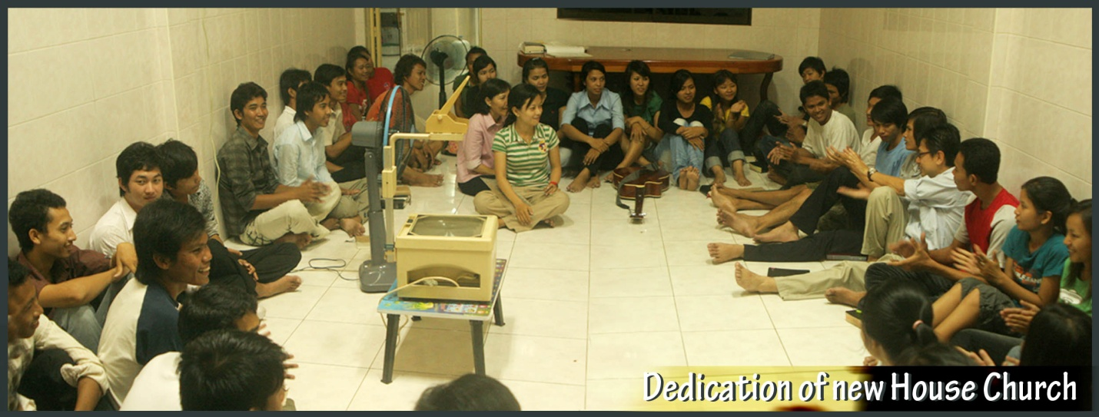
This house church of the Crossroads will function to serve ‘wine’ to the university students. They shall be filled with blessing and favor of God(OT meaning of wine). Please pray that this house church will always change water to wine. To rebuild and restore Cambodia is to cause Transformation. Please pray for its leader – Dalis; pray for new student intake; wisdom and strength in this power-encountering discipleship. Please pray for protection, His grace a mercy for deliverance.
Dalis(sitting in the middle herein) has been sent out to lead a new house church. While at the Crossroads she was active in leadership and also gain experience in leading small groups. One of the Crossroads philosophies is not to prepare students for ministry, but through ministry. While we acknowledged that she is not perfect upon her graduation, but we trust that the Lord will continue to mold her to perfect maturity in Christ. So, like other working adult, she will go to work in the day but will also set aside time to nurture university students – Turning Water into Wine. Please pray that this small step at the Crossroads will lead us to Restore and Rebuild Cambodia. Please PRAY for God’s protection on her child going out to serve Him; pray for Dalis’ heart of holiness and godliness, with wisdom and strength in her daily life. We pray for more House Churches to be planted through the Crossroads that more university students will be transformed and be renewed in Christ.

Unreached people – Kuy(2nd feb)
One of the main reason to re-focus on the city ministry in year 2007 is partly to re-structure ministry and especialy missions approach of a church. The Crossroads desire strongly to be in step with God, more than adopting or adapting human ministry strategy. We praise the Lord that the Crossroads church has been giving faithfully and their sacrifice is now used by God to preach the gospel to the unreached people in this county.
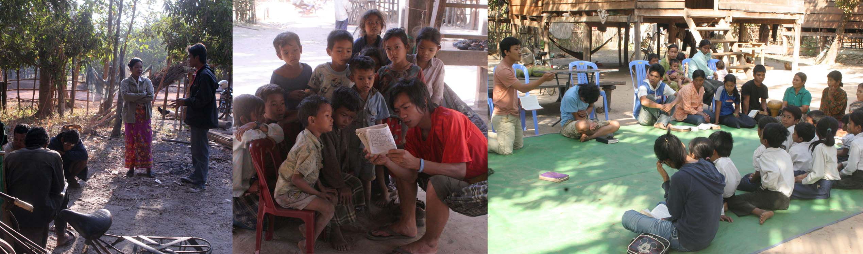
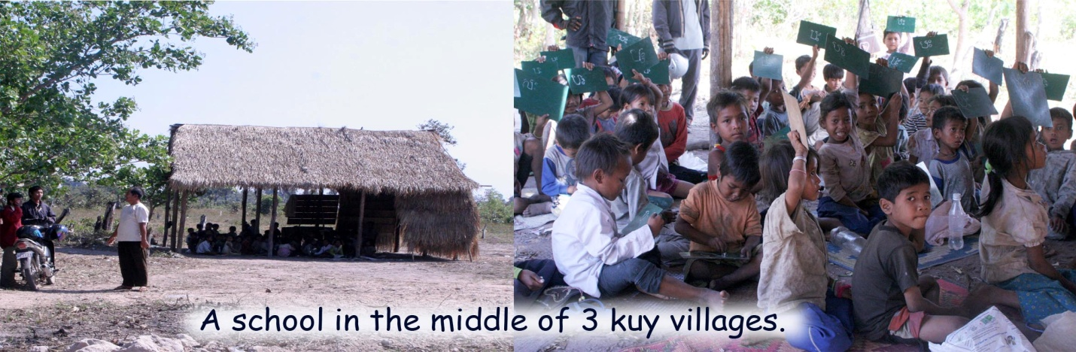
The Kuy vision further became a burden when the Crossroads church noticed that missionary in Cambodia, who are not fluent in Khmer language, have been story-telling the bible to the unreached people. When the missionary scheduled a 2 hours training for the Crossroads story team, each student took only 5 minutes to be equipped. The Lord has already blessed the church with such a talent, a very basic ability; and like the boy in the Feeding of 5000, we offered it back to the Lord. So, we are all looking forward to witness in Aug/Sept 2009 where the Lord will multiply to bless the Kuy people. Please remember us
The Crossroads team plans to visit the Kuy people this summer. It plans to empower the people with agricultural technique to elevate their poverty thus to story-telling as they live together with the Kuy people. We would need your prayer and support and trust that we would reap manifolds. We await to rejoice and celebrate with you.

conclusions
As always, we end with Ps. 127:1 - Unless the Lord ﻿builds the house, they labor in vain who build it; Unless the Lord ﻿guards the city, the watchman keeps awake in vain. We praise the Lord for all the things he has done. We have been blessed and it is our desire to be a blessing to all around. Indeed, may the Lord take our hands, feet, our body, our all to manifest Himself thus to use the Crossroads for His glory.
Dated this 5th day of May year 2009

