the crossroads 2010
This year will make 10th anniversary for the Xroads. Where are we right now? The Xroads started with a dormitory to house university students from all over Cambodia who had come to Phnom Penh city for their tertiary education. While providing lodging for them, its primary focus was on leadership and discipleship making. With the truth and the philosophy of life-influence-life, missionaries lived under one roof with the students and, therefore, leading them to come to the Lord thus mature in Christ.

Soon, more house churches were planted amongst university students. By the grace of the Lord, we have now 5 churches and 5 house churches. Last year, the Lord led us to two(2) new ministries, namely the unreached people group – Kuy People, and Enterprise ministry. Both the ministries have given us new platform for empowering these young believers thus to expand the kingdom of God in Cambodia. This year, the Xroads seeks to plant 3 more House Churches and 3 more churches in Kuy villages amongst the work of Christ centered disciple-making amongst Cambodian university students in Phnom Penh.
We have been very blessed by your support both financially and prayer intercession. The ministry continues to thrive in the midst of globalization. There is much to learn and many more marvelous work of God yet to be seen. Look at the nations and watch – and be utterly amazed. For I am going to do something in your days that you would not believe, even if you were told.[ Hab. 1:5]. So, as the Xroads grow, we still find ourselves deriving strength in His Word and prayer. It is our conviction that the ministry of Word and prayer shall be our foundation, that Christ is all and is in all.

is it worth it?
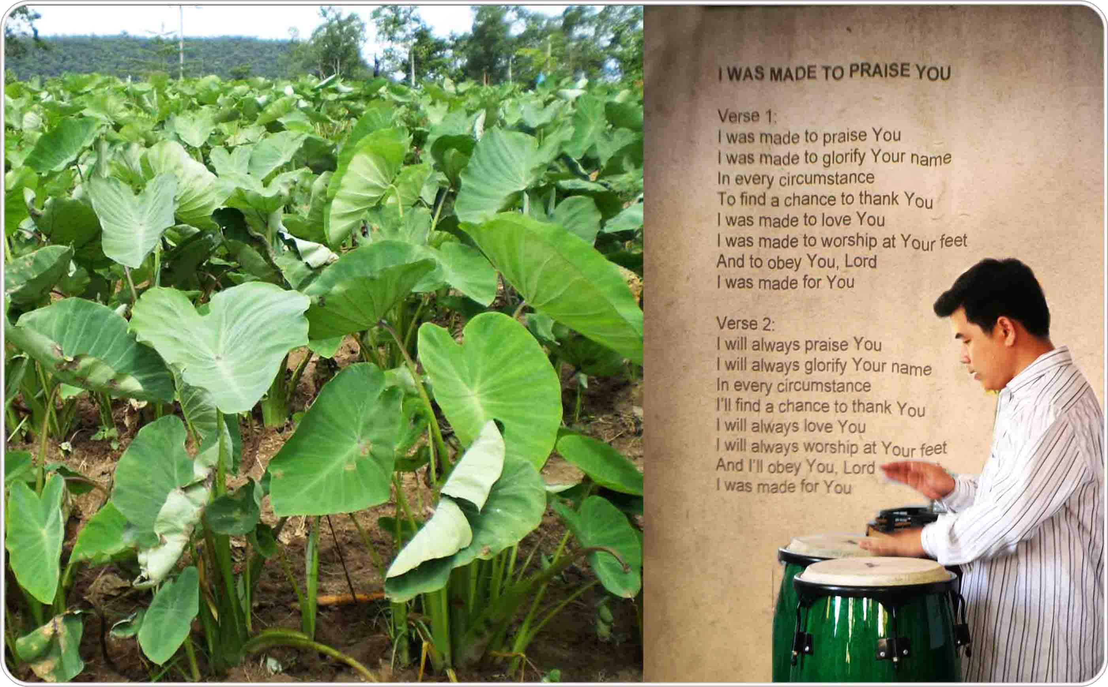
Karanin’s first harvest had just passed by. We were all expecting the Lord to bless our faithful brother, who is also a High School teacher and church planter. However, as the harvest was approaching, the crops were attacked by disease. Anxiety set into not just Karanin, but the whole church community as well. Is God good all the time? A further blow was inflicted when the market price for Taro dropped drastically due to market price manipulation by some people.
In certain ways, the enterprise suffered a slight loss though we have learned much. God is certainly in our midst all the time. The community got to witness the goodness of God in reality thus giving Him the praise. Two issues that are worth mentioning by the first harvest:-
- Karanin’s father(a strong animist) acknowledged that his god is not powerful enough, and had willingly came to seek refuge in our God. He came to church times for prayer to our God. He asked for prayer each time he joined us. Is the financial loss(about USD900) worth it in the context of salvation to the household?
- Enterprise is a mean that God uses to be bless us, but its primary focus still remain – Man exist to worship and praise Him. In all circumstance, Karanin has consistently demonstrated his genuine and trusting faith in God, on why we all exist. God has taught us all a precious lesson through this enterprise, and certainly through Karanin’s life. We joined him to Praise the Lord.
Please continue to pray for Karanin future undertaking. He is a righteous man of God in our midst. He has willingly allowed God to work in him that God can work through him. He is precious to God and to the Xroads.

ready, set, go!!!
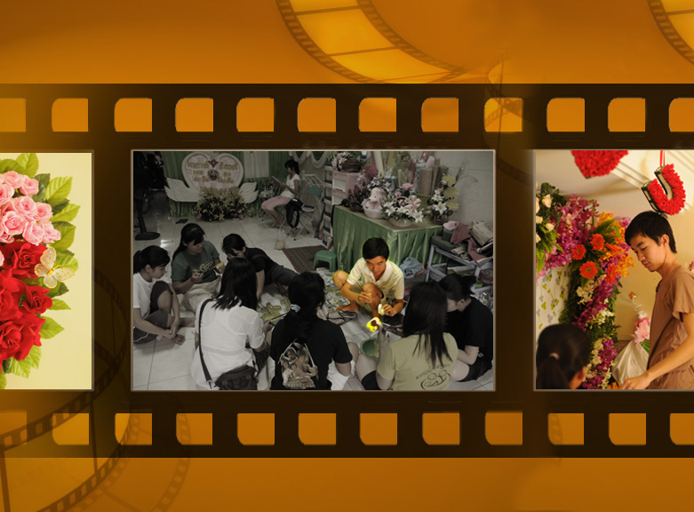
Sothea graduated in 2007. In the course of it, his life surrendered for God has been obvious. Upon graduation, Sothea was advised and guided to work for 3 years to gain social experience despite his desire to serve God full-time. He was given a God-given opportunity to run a decoration business under his grandmother. However, he had to weather severe hardship as living in peace with his grandmother was very challenging. Very often, he was treated unjustly and had to take all blame without any retaliation. We trust that such experience would be necessary and fundamental to future ‘suffering’.
By the grace of God, 3 years passed by. The hardship has transpired to be a training ground for Sothea’s fitness for and in ministry. He has done his best to present himself to God as one approved, a workman who does not need to be ashamed and who correctly handles the word of truth. With that, he was given a loan of USD10, 000.00 to set up a micro-enterprise.
Today, his enterprise is doing well and Sothea is also part of the Xroads disciple-making team and a House Church planter. As his enterprise generates income for church planting purpose, His presence has also challenged more Xroads’ students to be effective salt and light of the world that will accomplish the calling of the Great Commission of the Lord. Sothea’s life is not merely a glimpse of hope but has given us a sense of reality on our vision to Rebuild and Restore Cambodia.

Kuy people
Last year, we started the Kuy ministry, a minority unreached people group in Cambodia. The village is about 5-6 hours motorbike ride from the Xroads, Phnom Penh. Adapting the strategy of Luke 10 where Jesus had sent out 72 disciples 2-by-2, we sent out 18 people to comb through 3 villages the Lord has led to us to seek the Men of Peace. You can watch the highlights at http://www.youtube.com/watch?v=VRVXwdHIKsg
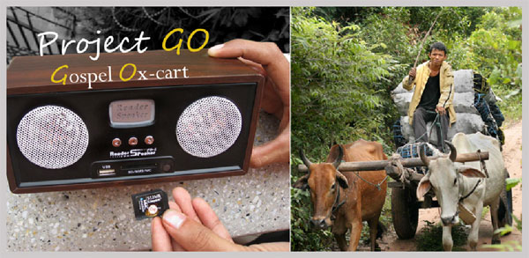
Kuy people is mostly illiterate and is without a bible in their own language. As we are praying for Abundant Gospel Sowing amongst Kuy people, we have been envisioned with Project Gospel Ox-cart(GO!). One of the main occupation for Kuy men is ox-carting, carrying the fruit of their labor(i.e pic left below). These people travel a lot and would need 'companionship' for travel.
We have been led to buy a machine/speaker that we can insert memory cards that will be downloaded with the gospel of John in Khmer language. As we have been sending out teams every alternate week, we are planning for some team members to be traveling companion with the Ox-cart rider. He will be playing bible stories to sow gospel seeds in them and people around. Please pray that God will use Project GO to spread His words thus to build His church amongst Kuy people.
Early this year, the Lord has led us to check out the land where Kuy people is concentrating in Cambodia. This location in Chasaen District is about 12 hours motorbike ride from Phnom Penh. On 4th Jan 2010, the survey team(David, Karano, Bora and Borei) had spied the land. This survey will help the Crossroads to decide and administer Kuy ministry which the Lord has entrusted the Crossroads more efficiently. We desire and ask that more Kuy churches be planted in 2010. Please pray for journey mercy, for protection from the power of darkness, and wisdom and discernment in decision making in the process of church planting.

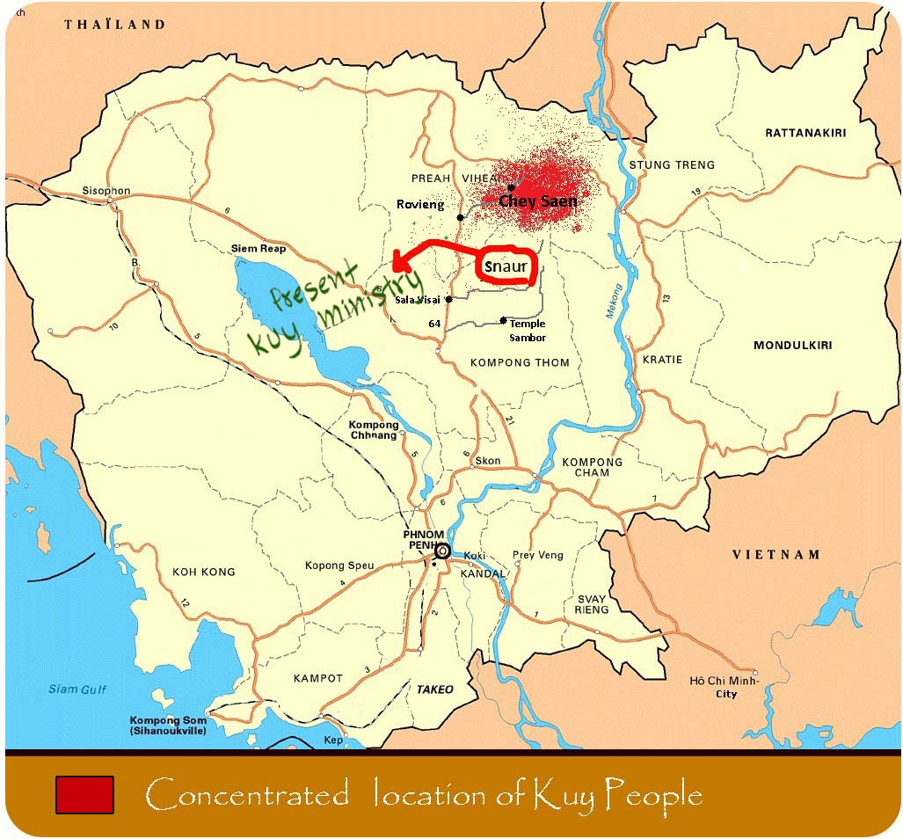

Men of peace
When Typhoon Ketsana came recently, a team of us was caught by it on our visit to Snaur Village( where the Kuy people lives). The Lord opened our hearts and eyes and realized the desperate need of uncle Hun, our Men of Peace. The roof was leaking and throughout the storm, his family has no shelter to sleep under. A few of us slept in a wet hammock under his house. In the cold, we prayed and pondered upon His cry and what He would want us to do for this village. Please pray for wisdom as we become a channel of blessing for uncle Hun and this village.
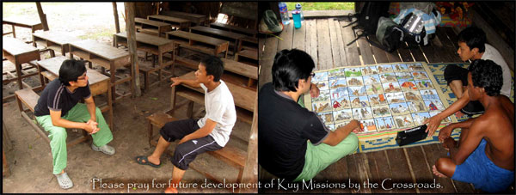
Uncle Hun continued to learn His word, thus is increasing in faith. When we were going through some bible pictures in the New Testament, he would even remember which chapter number in the gospel of John(He had listened to the book of John more than 7 times). We really regret that there is no Old Testament audio bible in Khmer language. Still, be praying as we will send team to be with uncle Hun every alternate week. Please pray for the Men of Peace to be equipped in His word. (He is now listening to the book of Acts). Please also pray that more Men of Peace be found and that a community of Christ be established at Snaur village.

City House church planting
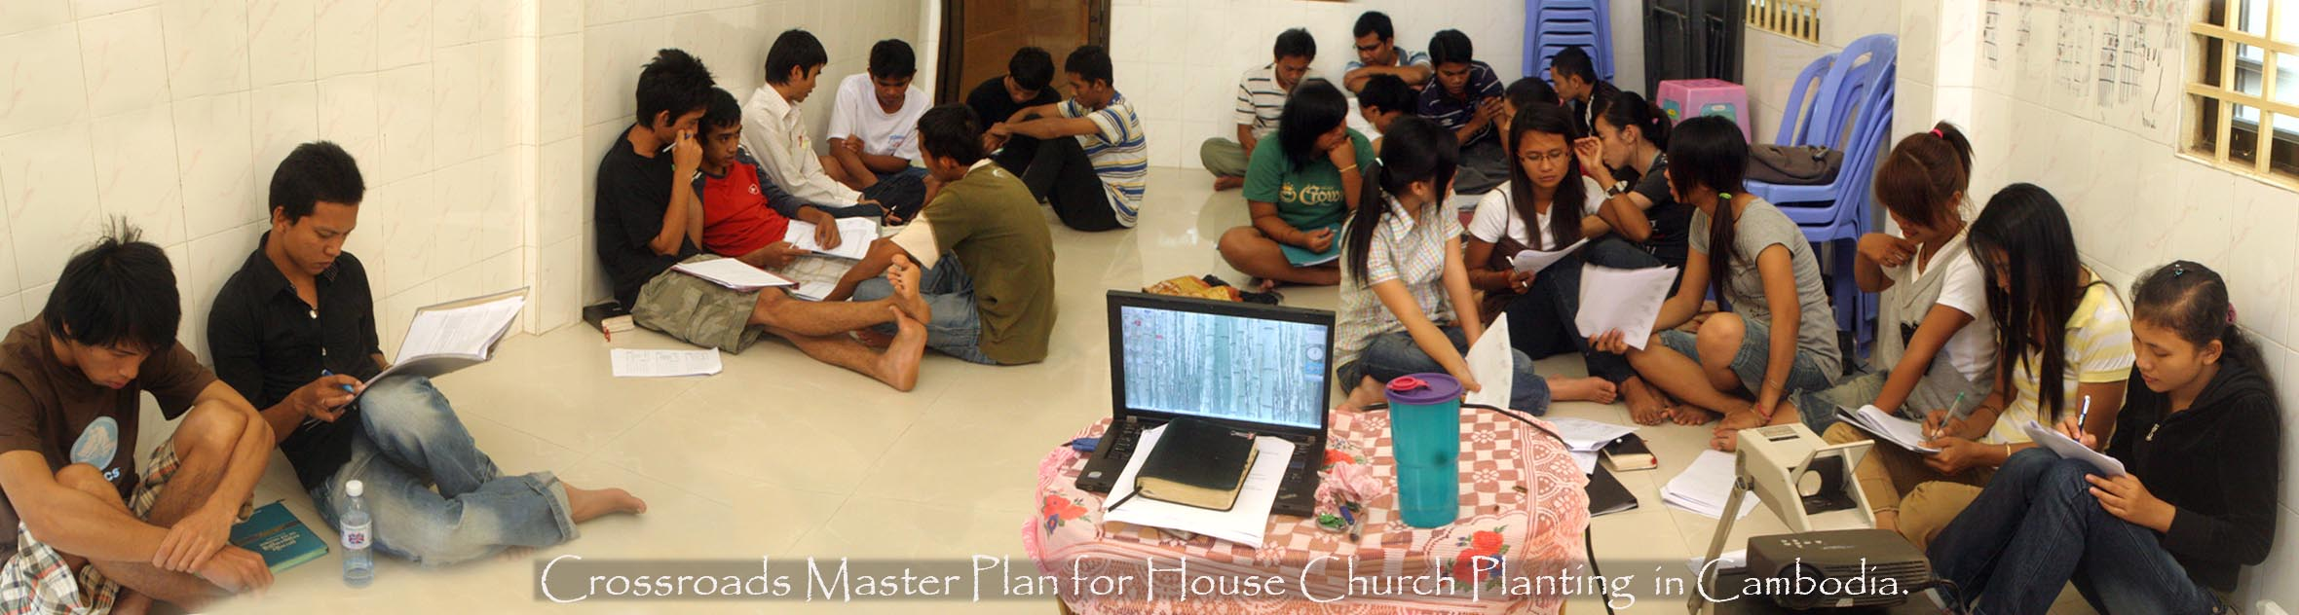
The Crossroads has re-consolidated its church planting strategy in Phnom Penh city. Interestingly, over the last 10 years, conversion of lives has been drastically reduced from an average of 3 years to 3 ONLY months. This has given us with a tremendous boost to use university students for church planting purpose.
With the influx or student migration(estimated to be about 180,000 high school graduate coming into the city for their tertiary education), the Crossroads is equipping itself with a Master Plan that more Christ centered disciples be raised through house church planting. As we lay this Master Plan on the altar, may the Lord be pleased and use it for His glory.

MIssion kids at work
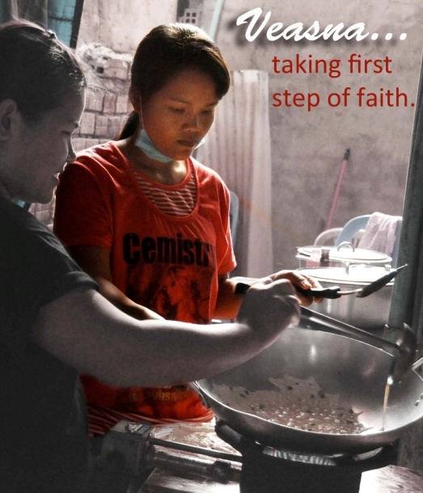
One day, a 'trick' question was posed - Who can carry a 1000 kg brick from the ground to the roof-top? Many were overwhelmed by the weight of 1000 kg but a little hand was raised. Rohaam answered that he could - by carrying one piece at a time. This prompted Veasna, a girls student, to take a step of faith - To believe in Jesus. Veasna had been wanting to belief but out of the fear of persecution, fear of being disowned by her parents and family, she had resisted and rejected the Lord’s salvation for her. Now, she has conquered her fear and worry and put her trust in the Lord. As she has been set free, she is preparing to share her faith with her aging parents.
Joey has been developing a personal conversation with God. She has been regular in her personal devotion time. Recently, while in anger, she was led to Psalm 2 which the Lord spoke to her personally thus calmed her anger down. Please pray for Joey’s spiritual growth that she will continue to grow in wisdom and stature, in favor with God and men.
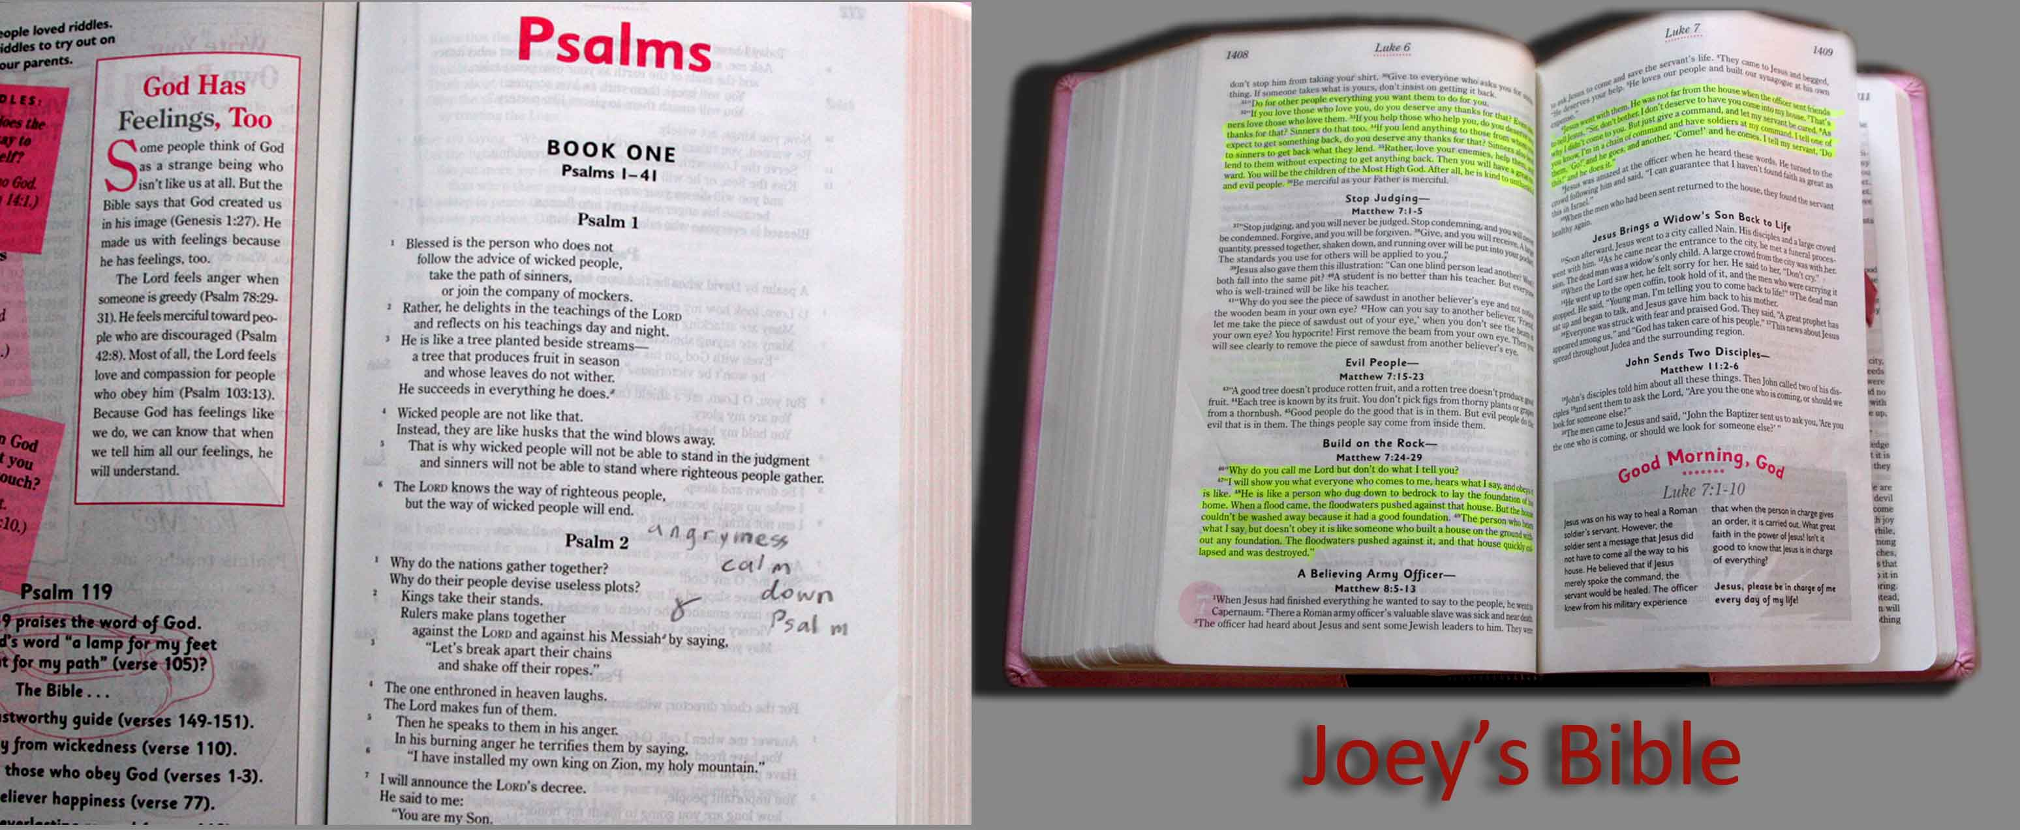

MIssion teams
Mission teams continue to be a fountain of blessing at the Xroads. Living with students when they are at the Xroads, they would conduct topical workshops & seminars, bible teaching, life sharing & testimonies, evangelistic outreach, and partnering Xroads in church planting.
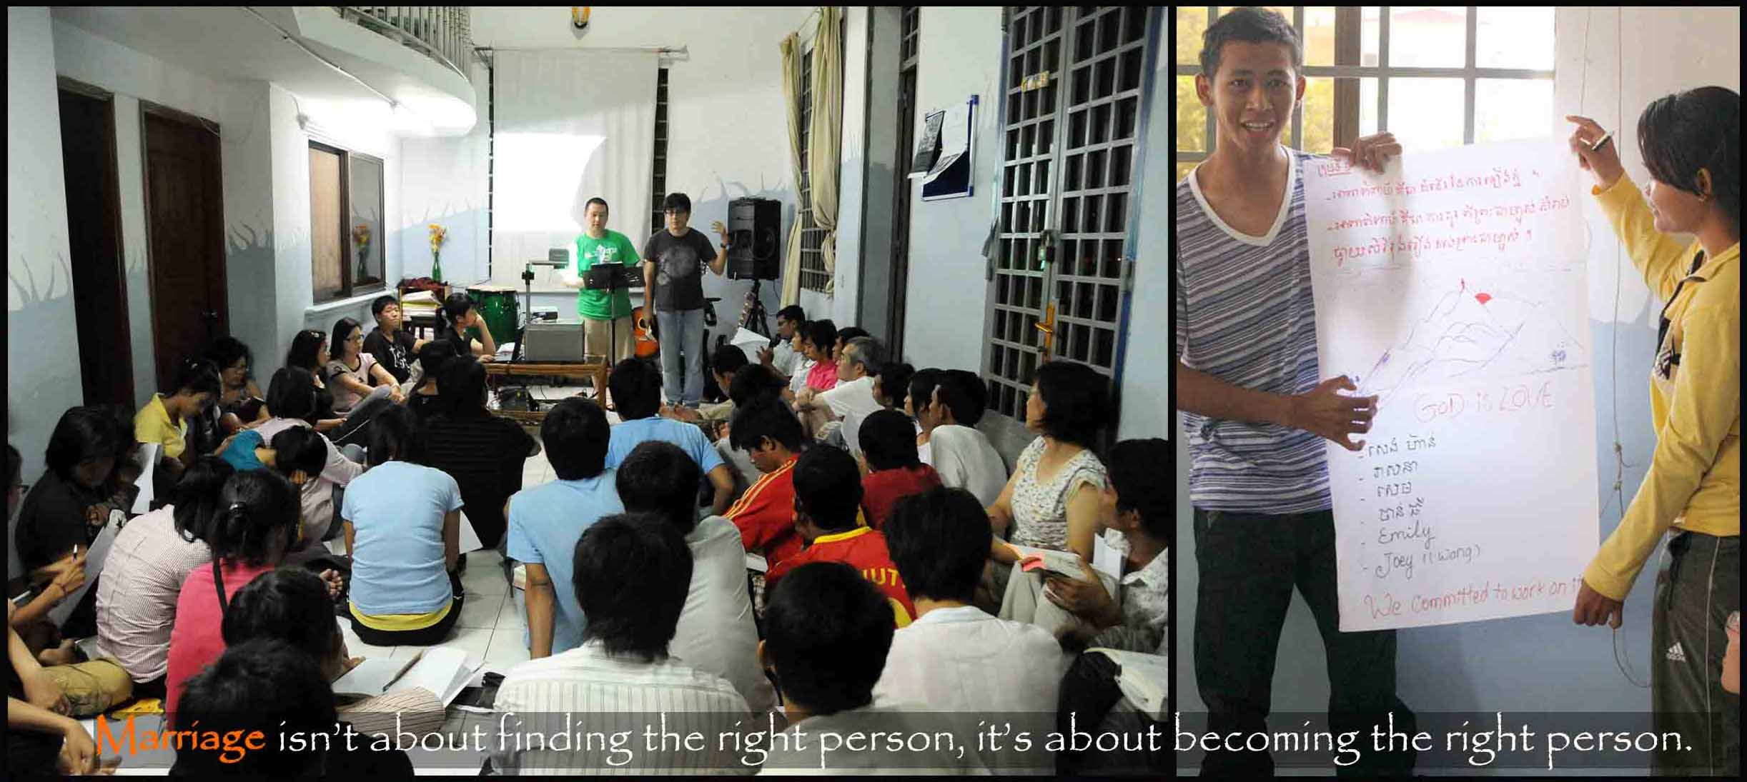
At team from San Jose came last August. Under guidance and adaptation, the team presented a biblical basis for marriage. This topic is one of the keys to the Xroads Rebuilding and Restoring Cambodia. On the other hand, this topic has also set the biblical standard of boys & girls relationship as far as His holiness in concerned. Through the preparation, seminars and teaching, the team has also been reminded of God’s holiness and His purpose for marriage, which turn out to be a blessing for them in return.
We would therefore welcome mission teams to visit and partner us for ministry at the Xroads. We have witnessed the Lord using many different people in various capacities and setting to accomplish His Great Commission.

conclusion
Last Christmas, we had an evangelistic meeting. Students from the Xroads invited their friends to join the celebration in which we had also presented the gospel to them. You can view the highlight at http://www.youtube.com/watch?v=Ij4i568Aj7Q . We praise the Lord and trust that all our labor in the Lord is not in vain.
Once again, we thank you for your involvement in our ministry. Your prayer support is a real encouragement to us, and your financial support is our answer prayer from the Lord. We continue to move and manage forward by faith trusting that He who has began the good work will complete it when the day He comes.
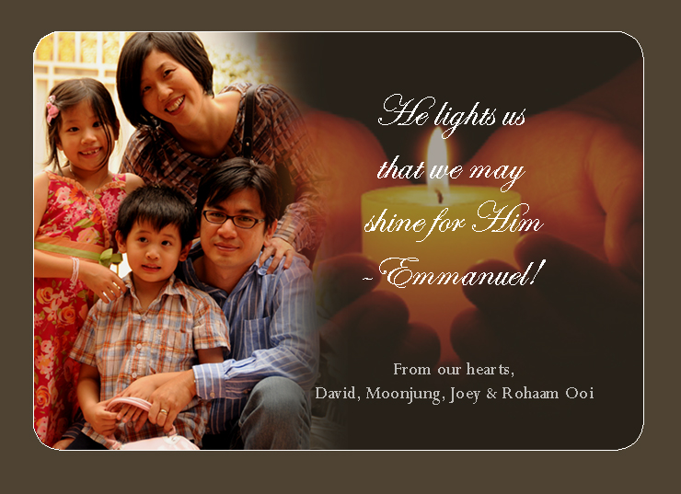

Dated this Day 26th Month January Year 2010.

