The Crossroads Report Aug 2010
Prayer and Progress Report

The Crossroads

August 31, 2010
Authored by: David Ooi

The Crossroads Report Aug 2010
Prayer and Progress Report
The Crossroads
In year 2010, a record of 90,000 from all Cambodian high school students graduated and studied in Phnom Penh. It is estimated that in year 2012, about 180,000 high school students will graduate thus to migrate to the already overcrowded Phnom Penh to pursue higher education. This category of the society, who is seen as the hope for the future of this broken nation, has the greatest potential to cause transformation and to bring hope for Cambodia.
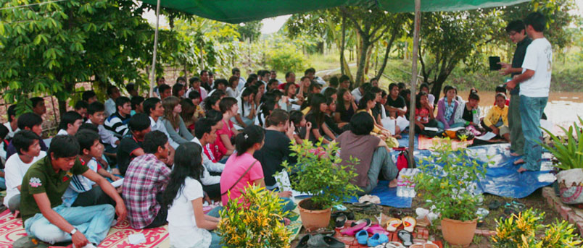
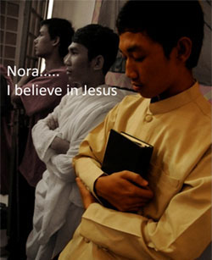
The Crossroads is committed to develop Christ Centered Disciples of Cambodian University students in Phnom Penh. Since year 2000, many have come to know Christ and being disciples for church mobilization and multiplication. In August 2010, 12 more university students were baptized to carry the Cross despite strong persecution from their families and friends. We all shared the common vision – To Rebuild and Restore Cambodia.
Nora was repeatedly threatened by his parents to leave the Crossroads. On the one hand, the parents acknowledged Crossroads contribution to Nora’s maturity and growth as a young man since he moved in to live at the Crossroads. On the other hand, due to their strong association with Buddhism, they are worried that they will lose their child who was brought up to gratify Buddha.
Yet, Nora’s faith never waived. On the day he was to be baptized, his parents further threatened to severe their relationship ties with Nora. Nora withdrew and professed his love for his parents that nothing will take away his love for them. However, he added that still, he would not disown his faith in the Lord. With his hands, tied, Nora was forced to moved out of the Crossroads but remain active in his faith and the community life at Crossroads. His faith has continued to increase. Please pray for Nora that his faith will be deeply rooted in Christ. Also, may Nora’s experience be a stepping stone to many others who would face persecution due to their faith.
House of Cana: Vision and Mission
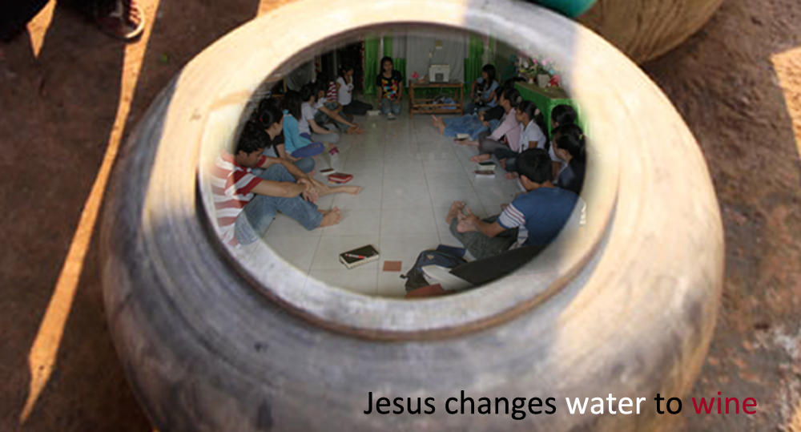
When House of Cana was planted, the Lord gave us a vision in John 2 – to transform water into wine. Naturally, and the way in which the ministry has developed over the last decade, we thought that the Lord has called us to bring healing and restoration for many university girls students. But God has planned otherwise. He slowly led us and prepared ways for us to be in touch with girls under exploitation. While the church struggled to cope with class of society(university and girls under- exploitation are in different social class in Cambodia), the church pressed on to seek His vision. As at now, and by His grace, we are convinced that the university student girls at Cana will be discipled to serve and minister to women under exploitation. And as at now, we know that we are ready to serve the wine. May His angel go forth to prepare the way for us.
Unreached People Ministry: Kuy People
Last year, the church explored and ventured with the Spirit to find Men of Peace amongst Kuy people, an unreached people group in Cambodia. We were determined to pour out to sow abundant gospel seeds amongst them. Church leaders and students would take turn as team to travel 6-7 hours’ journey one way, sometimes, 14 hours in order to seek Kuy villages, and especially the Men of Peace.
As the Spirit would lead us, we faithfully developed relationship with the Kuy people. Last year, we arrived at Snaur and for year 2010, we set 3 villages – Sukrun, Jehok’nah and T’bit, which we have accomplished. We praise the Lord that all these hardship were paid off as believers were found and baptized. Please pray for the young Kuy church to be nurtured and grow in His words despite their illiteracy and distance from us.
Pepper Enterprise
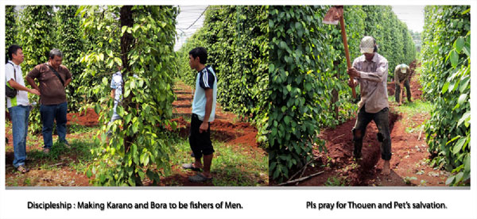
In the gospel of Luke, it was recorded for us that there were existing political, financial and social problems. Oppression, physical, emotional and spiritual, was to full extend. People were in poverty thus being imprisonment politically, economically and socially. There was also a need for God to give recovery of sight for the blind. Hence, Jesus was commissioned to preach good news, to proclaim the year of the Lord’s favor(Luke 4:18-5:11).
We praise the Lord for commissioning Crossroads to empower people like Bora and Karano to do the same - Making fishers of men. The discipleship journey ahead is challenging, and sometimes overwhelming. Once, a rich business approached us to help him out in his plantation. We certainly have the skill(by the grace of God), but how do we be a blessing to them can be tricky. We pray for wisdom and discernment in poverty elevation, in preaching the gospel, and more so, to make Christ Centered Disciples in Cambodia as we rebuild and restore this broken nation.
Thouen and Pet are young people from Kuy villages we have reached out. They have been employed to work at our pepper farm, almost 300 km from their village. We pray for their salvation. Interestingly, owners of adjacent land have questioned us on where did we get our employees/laborers. They commented that our employees/laborers are diligent and hardworking. We were encouraged to receive such comment as we seek to be light and salt of the area. Please pray that His glory consistently and continuously be revealed to overpower the evil power that has been manipulating people there.
Transforming Community – Mekong University
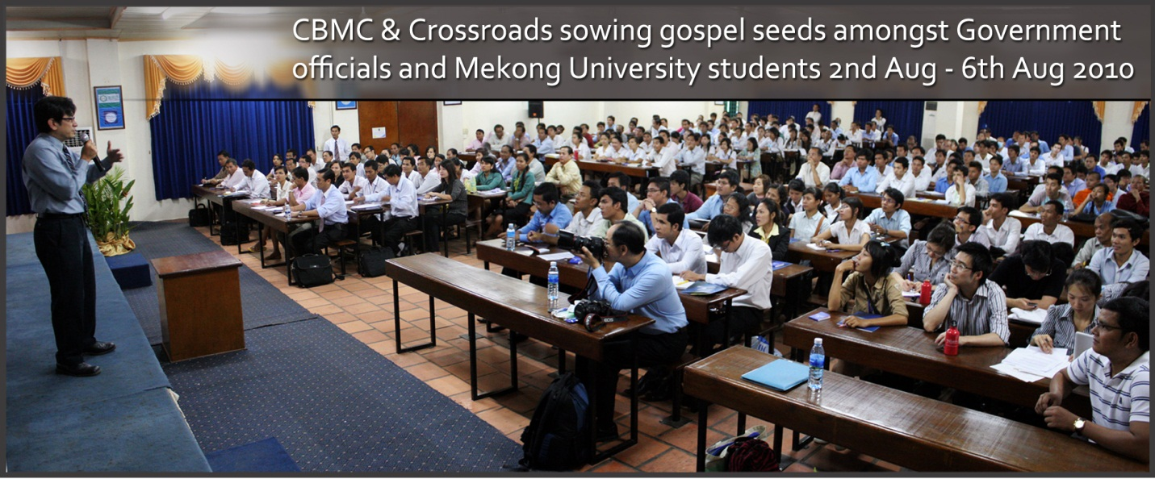
In Aug, the Crossroads poured out to conduct a seminar on '7 Habits of Highly Effective People' in partnership with CBMC, Alhambra, CA, USA. We are thankful to have accomplished a wonderful week of abundant gospel sowing amongst 150 university students at Mekong University and also 200 senior civil servants and government officials. Some companies, local organizations and even monks(see middle of photo above) also attended.
We now have 5 other invitations, one from another local university, another from a private training center, and 3 others from various government departments to conduct the same. We praise the Lord and thank Him for He has done great things. And we pray for wisdom on our future undertaking to rebuild and restore Cambodia.
Conclusion
One of the greatest breakthrough this year at the Crossroads has to be the vivid transformation of heart and mind of believers. The spirit of poverty and timidity has possessed and damaged the lives of many Cambodians. Organizations and churches have come and gone. Material wealth has been poured out as well by many generous donors. However, who can restore the heart of a broken soul? Students at Crossroads were once very negative and passive in nature. By the grace of God, and obviously through the working of the Holy Spirit, He has transformed them all. ‘I can do it!’ Such is the conviction of the believers. In beginning of 2010, the church pledged to plant 3 House Churches, but right after the retreat(pic herein), the group pledges 5 House Churches. This is a miracle indeed.
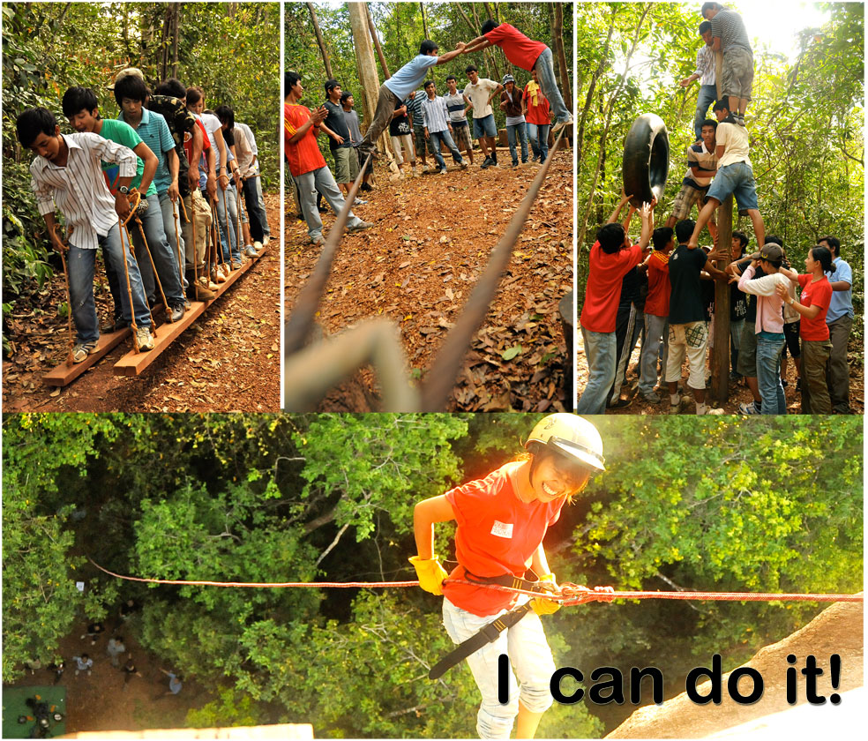
We thank you for your support and prayer. We trust that the Lord will continue to complete many good things that He has commenced at the Crossroads. We look forward to report His great work to you soon.

