The Crossroads Report Jan 2011
Prayer and Progress Report

The Crossroads

January 10, 2011
Authored by: David Ooi

The Crossroads Report Jan 2011
Prayer and Progress Report

Introduction
The Crossroads, established year 2000, commenced year 2010 with a commitment on Managing Forward[see chart below]. After 10 years of ministry, it was necessary to review and preview what would the Lord be entrusting us in the near future. By faith, we stepped forward treasuring up all the things that the Lord has committed in our heart and pondering upon them consistently – “… For I am going to do something in your days that you would not believe, even if you were told.”

What has happened? As at December 31, 2010, we witnessed the following:-
- Commencement of Enterprise and Micro-Enterprise Ministry;
- Commencement of new Xroads ministry in Vietnam;
- Commencement of 2 churches in amongst Kuy people, an unreached people group in Cambodia;
- Commencement of 2 house churches in Phnom Penh.
We ended year 2010 with a statement – We walk by faith, not by sight II Cor. 5:7. God is good indeed, and above all, God is great. He is worthy of our praise for His is the kingdom, the power and the glory forever and ever, Amen.

The Crossroads
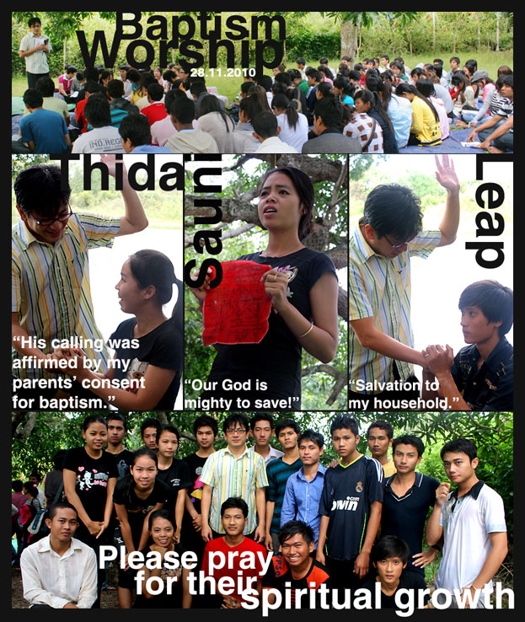
The Crossroads’ vision is to rebuild and restore Cambodia. The Crossroads is a discipleship ministry to develop Cambodia University students as Christ centered disciples. In a society where Christianity is strongly resisted, the Crossroads establishes Christian dormitories where students reside. The students thus go to school in daytime while study His words by night daily.

The Crossroads has now 7 house churches at Phnom Penh, Cambodia. By year 2012, it is estimated that there will be about 180,000 high school graduates. This figure is doubled of the present statistic due to a change in school curriculum a few years ago. The Crossroads is now, therefore, riding on the waves of opportunity to plant 20 house churches by year 2012 by the grace of God.
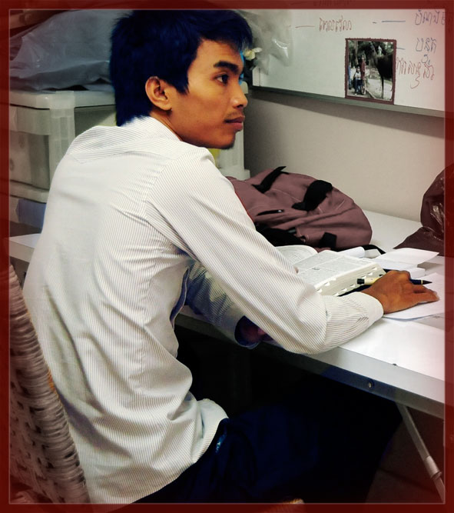
Rathana came to Crossroads in year 2005. While at a crossroad, he was called to follow Jesus in which he obeyed whole-heartedly. Rathana’s strong desire for His words allowed God to work in him and as a 3rd year student then, he professed that he would lay down his life for Jesus(John 13:37). Hence, a second calling to ‘Follow me’ was completed.
In His time, and by His grace, God began to work through Rathana. Rathana’s commitment to bear His cross daily and his character transformation was vividly transparent for all to see. When he was at the end of himself, not in imagination but in reality, Jesus invited him to ‘Follow me’ again. By the leading of the Holy Spirit, and being in step with him, Rathana was then commissioned to lead plant a church with a team of 2 other brothers.
Today, the Pillars, led by Pastor Rathana, is a young but growing into maturity church. The church has found its own identity with its own purpose and ministry. By the end of last year, they have planted another house church. The Pillars is indeed a fruit of the Spirit by the grace of God. Truly, unless a kernel of wheat does not fall onto the ground and dies, it cannot bear much fruit. We have witnessed the truth through Rathana’s character transformation and His commitment to the Lord.
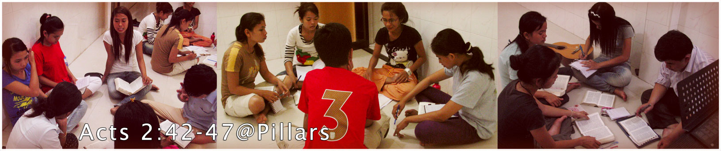

House of Adullam
We present you House of Adullam, an extension of the Crossroads. This was established in October 2010 in preparation of the influx of migration of high school leavers in year 2012. We desired and planned that this house will multiply into 5 House Churches at Phnom Penh by end of year 2012. This is based on 1 bSamuel 22:1-5, the initial gathering and beginning of King David’s kingdom and how they would later be scattered in the land of Judah.
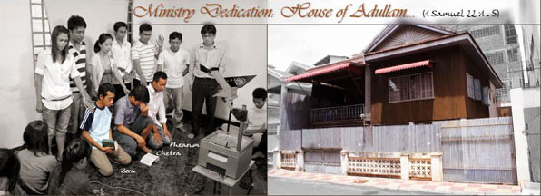
As we commenced to pray and seek His direction since May 2010, the Lord sent us partnering churches from Malaysia. During their visit to the Crossroads, the Lord impressed on its leadership His vision and with His amazing power, both churches have willingly obeyed to providing financial and prayer support to rent a new house in accordance to our vision. God is indeed the Jehovah Jireh that has encouraged us to press on in walking by faith and not by sight.
Please pray for its leadership - Bora, Chetra and Pherum. At the moment, it has 13 residents, and it will increase to 28-30 residents by end 2011. Please also pray for its leadership development and character transformation that they will be empowered by His word and Spirit for His glory.

Enterprise Ministry
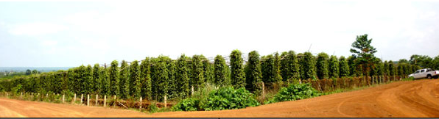
With its vision to rebuild and restore Cambodia and its goal of 20 House Churches by year 2012, the Crossroads church, by faith, took out a loan of USD130,000.00 to buy a pepper plantation at Da Commune, Kampong Cham, Cambodia. The Lord has sent us His instrument to provide the consultation and expertise needed for such a massive mission.
Besides the enterprise ministry’s goal to generate and supply income rental houses in Phnom Penh city, the Crossroads has also undertaken a mission to preach and evangelize to the poor and oppressed farmers. Further, the ministry has also provided another discipleship platform for us that more students and graduated students’ character can be shaped by the Creator for His use. Please pray that the eyes of our hearts may be enlightened in order that we may know 1)the hope to which He has called us, 2)the riches of His glorious inheritance in us, and 3)His incomparably great power for us as we managed forward.
Though the harvest is estimated to be in the month of April-May 2011, we have already begun harvesting. Looking at the plant itself and the plantation as a whole, we are expecting a great harvest. Comparing to the neighboring plantation, we are expecting a double harvest; yes, God is giving us a “double portion” of His blessing. Please pray that this enterprise will be a channel of blessing to rebuild and restore Cambodia.

Kuy People Ministry
In February 2009, we began Kuy ministry. It was another action of faith as the Kuy people location is very far from Phnom Penh where we are stationed. Every month, sometimes twice a month, we would go out in bikes 6 hours one way deep into the forest to be with the Kuy people. We came first to Snaur village, then Tronaek and to Sukrun then to Jehok’nah and T’bit.
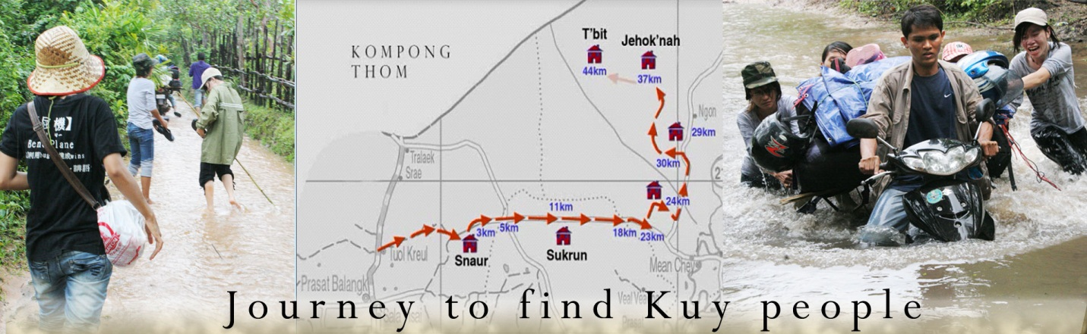Through the friendship the Lord has blessed, we sow His seeds. We praised the Lord for His greatness. His salvation has been confirmed at Snaur and Sukrun. Praise the Lord for His work in and through the Man of Peace, Uncle Hun. God has used him to win over his brothers. Amongst the 7 families baptized,4 of them were elders of the Village. Please continue that He will complete the good work that He himself has started. We continue to visit them and will help them to lead themselves thus to be mature in Christ.
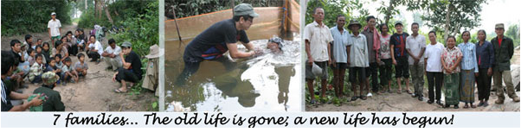This little community in Snaur is now a heaven on earth. The heaven is now visible through them at Snaur village. We got them to think and develop intentionally that all Snaur villagers will enter kingdom of God, and beyond. Please pray that through this development, they will grow mature in faith making disciples of all Kuy people. Please pray for the following:-
- Growing of Kuy churches into maturity in Christ;
- Leadership and governance of the church;
- Salvation to more Kuy villages and people.
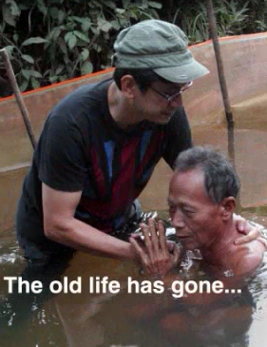
When we first arrived at Snaur village seeking for the Men of Peace, we were opposed by local authority and the local village sorcerer. Though we were led to the Man Of Peace in Uncle Hun, the chief villager and the sorcerer, Uncle Chaen were hostile to us. “Have you gotten authority to come to this village?” asked the chief villager. At the same time, Uncle Chaen made evil spells against us. We held onto His promises trusting that He would deliver us as we fought the spiritual warfare.
Over a period of time, this relationship was seemingly getting nowhere until one day, when Uncle Hun, the chief villager and a group of men went out to chop wood in the jungle. After they prayed for protection, a routine before chopping, they began. As they chopped wood, the chief villager was blinded by a small piece of wood that sprung back. Word went around in the village that uncle Hun’s God is more powerful than the chief villager’s.
The gospel was eventually preached to the villagers. Many believed and repented. Amongst this group of people was Uncle Chaen. He has also experienced the power of God and decided to submit under the mighty power and sovereignty of God. His belief and repentance was also a great witness to many people and suddenly, almost the whole village is coming to Christ. Isn’t God amazing?
By end of this month, we will continue to send teams to strengthen our Kuy brother and sister. There are many wonderful and amazing things that the Lord has been doing and we pray that we will not missed a single one of them. Instead, may we be wise and continuously discern that we will abide in the steps of the Spirit.
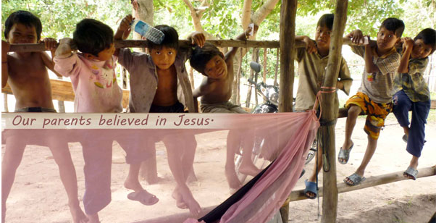

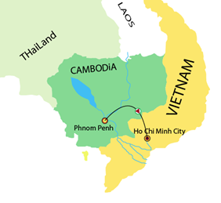
Crossroads, Vietnam
One of the many other blessings last year was to witness how the Lord has opened up a door to mobilize university students and professionals at Ho Chi Minh city for His kingdom. After we have been praying for close to a year, our prayer was suddenly answered. We were led to a church in Vietnam to conduct training and from there on, the body of Christ was envisioned with passion to established and extend His kingdom in Vietnam.
Please pray for His words to spread in Vietnam and that His word will equip the saints to build the body of Christ until they attain maturity in Christ.

Conclusion: There are no ‘poopless’ cows
Proverbs 14:4 says, "Where no oxen are, the manger is clean, but much increase comes by the strength of the ox." Without the ox, who makes a mess, there won't be increase. If success is measured by a clean stall we create a system that removes risk and avoids discomfort. Those who have said an absolute "yes" of surrender to God, must go beyond the edge of comfort to attract breakthrough, revival, and increase we all long for, but be ready to endure rejection from the religious systems. God is looking for a people whose heart is entirely His, no matter the response of others. His glory will then be released through a display of power upon his people.

