The Crossroads Report May 2011
Prayer and Progress Report

The Crossroads

May 15, 2011
Authored by: David Ooi

The Crossroads Report May 2011
Prayer and Progress Report

The Crossroads
The Crossroads is coming to its 11th year anniversary since its establishment. We thank the Lord for He has enabled us to be faithful to our calling – To rebuild and restore Cambodia. We pressed on to make disciples of all nations, equipping Cambodian University students to be Christ Centered Disciples.
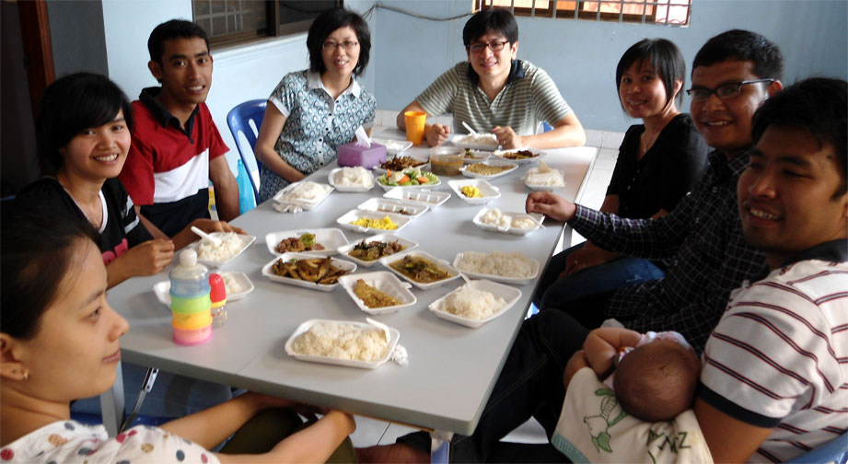
Over the years, we praise the Lord that many graduated students have also married. The ministry of rebuilding and restoring Cambodia is certainly inclusive of building up Christ centered family. We thank the Lord for Rithy and Dalis(and their baby girl, Reaksa, who supposedly address me as grandpa), Bora and Danet, & Vuth and Kalyan. Please pray for these young couples and families as we lead His church to be holy and acceptable in His sight. Please also pray for them that they will find wisdom and strength in the Lord as they faced challenges of young Christian families in a globalized world.

The ongoing persecution at Xroads
We have witnessed faith in Phi and Chantrea’s lives. However, in their recent home visit, their parents had learned about their faith and threatened them to leave Xroads. They are in dilemma now … the price of following Jesus. Pls pray for our students, especially girls, in their pursuit of faith in Christ.
In Cambodia, girls(daughters) are very much bounded by cultural and traditional practices. There are customary practices to adhere to regardless of what they think or how they feel; not encouraged to be literate, cleaning family altar for worship, going to wat thus following spiritual rituals, giving up their future and rights to sons and younger siblings, or worst, to be sold into prostitution and marriages in order to provide financially for their families. In darkness, they would protest not for such is their destiny as Buddhism would teach.
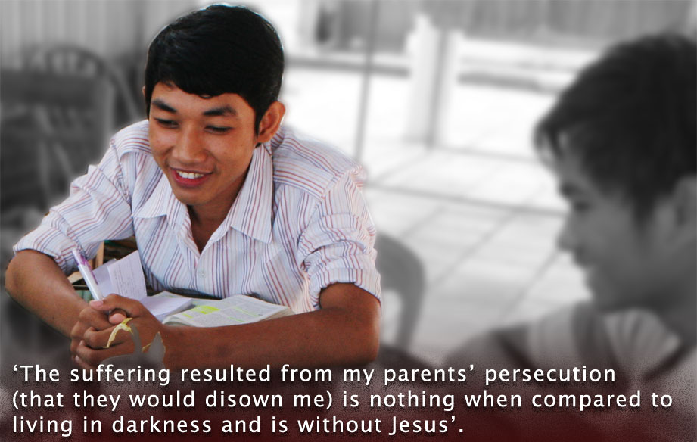
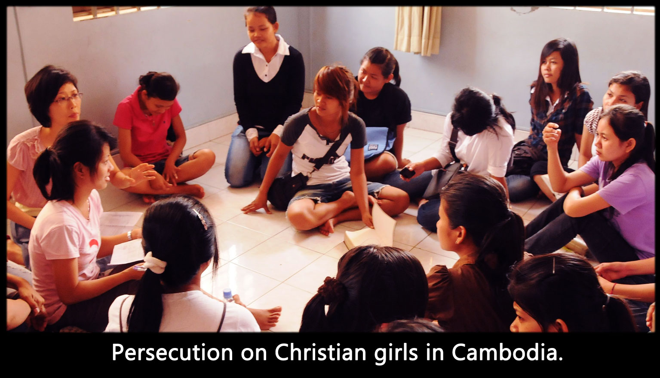
Therefore, girls at the Crossroads are constantly being bombarded by cultural and traditional issues. Such is the challenges of ministry in equipping Cambodian University girls students to mature in Christ. The pressure on the girls to conform to its cultural practice and the demand of the world on them do not give any chance for His seed to sprout and grow thus to bear fruit in their lives. Pls pray that they will be set free from the captive of hollow and deceptive philosophy on human tradition and the basic principles of the world(evil spirits). Pls pray for courage that their heart will set on Jesus alone. Please also pray for Xroads as it plays a pivotal ground for good soil to bear fruit many folds.
What do we do when students are persecuted? Nora has been persecuted by his parents for his faith. He was forced to move out of Xroads due to family persecution. His parents threatened to severe ties with him if he still believed in Jesus. He moved out to pacify his parents. In knowing the discouragement faced by students , he testified, ‘The suffering resulted from my parents’ persecution(that they would disown him) is nothing when compared to a life in darkness and is without Jesus’. Though Nora is a non-Xroads resident, he remains faithful to bear His cross daily.

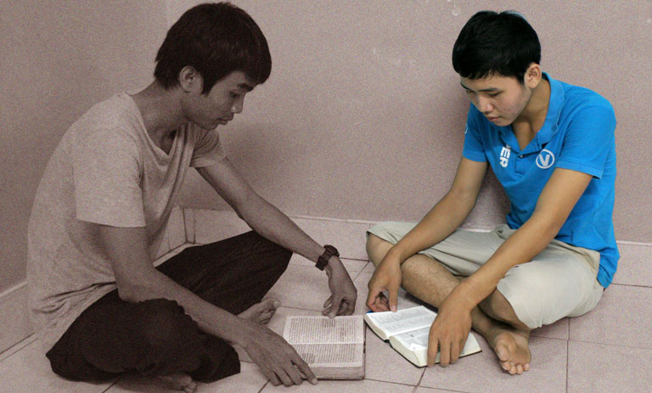
The truth shall set you free …
Borey grew up with his widowed mother. When he was 10 yrs old, his father passed away due to illness. Since a teenager, his life took a downturn – rebelled at home, cheated and misbehaved in school, fought and committed social illness. His mother parted with him with an accusation – You are so stubborn and no one can teach you.
Being hurt and broken hearted, he wandered off in life. He came to the Pillars, a ministry of Xroads, last year. He was totally being imprisoned by his past, especially the parting words of his mother. At Pillars, God began His handiwork in Borey as he seek and learned from His words. Pastor Rathana was compassionate and committed to impart God’s words onto Borey. In His grace, Borey’s saving faith then led him to be in contact with his mother. They stayed together a few days, and his mother testified, ‘My son, you have changed so much …’. Truly, His truth has set Borey free. Borey continued to learn His words at Pillars and his faith is growing consistently. Please pray for Borey, for His living faith to impact others, and for his future undertaking for His kingdom.

The Kuy Ministry
From our last report, we founded 2 churches in Snaur and Sukrun village. His work continues to grow as teams from Xroads and Pillars take turn to visit and disciple the young Kuy believers. Please pray for wisdom and strength as we continue to evangelize to this unreached people group in Cambodia.
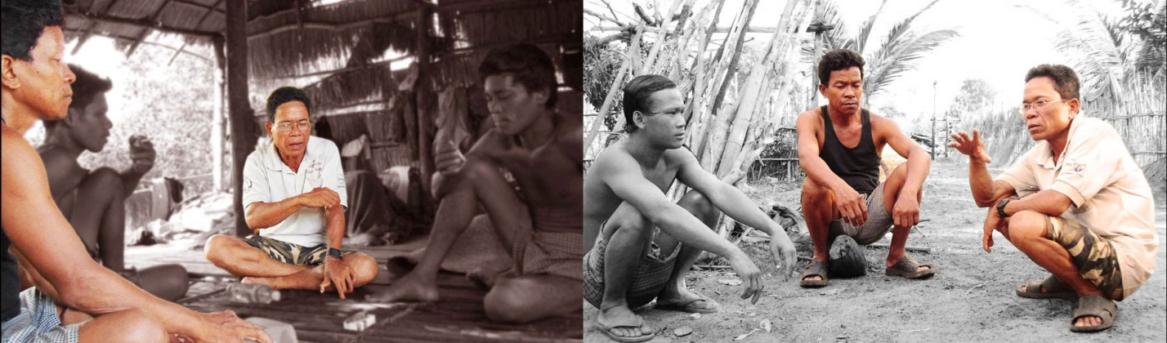
At Snaur village, we have found His abundant grace and amazing provision, as always. We had just baptized 7 families earlier this year and are in the midst of praying and seeking the Lord on how to establish church governance there. We praise the Lord for the faith of Uncle Lim, Hun and Cheng, whom are all elders(all 3 have already been baptized) at this village. They have been faithful in taking up ownership of the church. They exercised and demonstrated their faith by caring and evangelizing to folks in the village. Please pray that the Lord will continue to nurture and expand His kingdom in Snaur village through them.

Saving Faith, Living Faith …
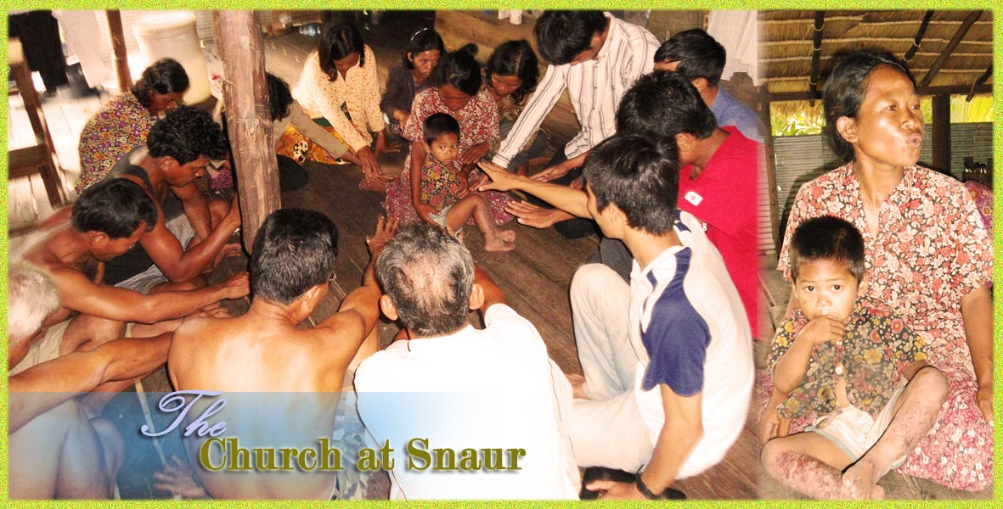
Aunt Mi has recently believed in Jesus. Unfortunately, she has had a miscarriage and was urged by her relatives and neighbors to seek the spirit whom they claimed she had offended and provoked. By faith, Aunt Mi didn’t conform. On Sunday, she testified that the Lord has given her a dream on heaven. With the courage, she testified and encouraged young believers to remain faithful to the only one true God. By His grace, God’s revelation has given her the courage to submit to God and resist the devil. Such a personal victory is yet another confirmation that Heaven has invaded Kuy people at Snaur village.

Bringing His words to Kuy people
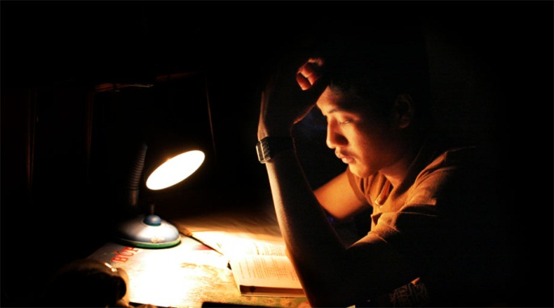
The Kuy people has yet to have bible in their own language. Since they are able to comprehend Khmer language sufficiently, we have been using Khmer audio bible in sharing and teaching them about God. However, there is only Khmer New Testament audio bible.
Pichet, a 2nd year university student has aspired to be a radio broadcaster. As the church’s ministry to Kuy people grows, the need for Old Testament bible became urgent. Just like little boy offered his 2 loaves and 5 fishes to Jesus, and so Pichet offered his time and dedication to make audio recording of Old Testament bible for Kuy people. Please pray for this project, and though it is nothing fancy nor professional, we ask that this commitment and simple act of faith will bring forth abundant blessing.

Enterprise Ministry
In middle of year 2010, the Crossroads Church was aware of the huge migration of high school students coming to Phnom Penh for their tertiary education. Apparently, the figure will double to an estimation of 180,000 in which the government has ‘surrendered’ in containing with the sudden influx. Is this a sudden social problem, or is that a wave of opportunity for His ministry? The church, capturing His vision, borrowed USD130,000.00 to purchase a 1.8 hectares pepper plantation in order to generate income to rent more houses in Phnom Penh city for dormitory purpose, a ministry that the Lord has called and prepared the Crossroads since year 2000.
Recently, we have had our first harvest. The pepper price has soared from USD2.20 when we first purchased the plantation to USD5.70 when we are harvesting. Obviously this venture is by faith and we are thankful to God on how He has miraculously orchestrated and assembled His people together to make this amazing work of His possible. Interestingly, no one is able to claim any glory in this piece of masterwork and truly, we give Him all the glory He is fully deserved.
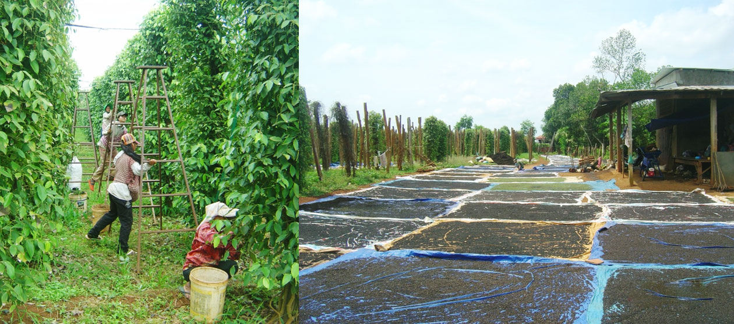
As the Lord has granted us this blessing for His and our pleasure, we are also reminded on how the Lord has warned the Israelites to observe His law and to obey Him faithfully as the Lord had given them the land filled with milk and honey(Deut.11:8-15). We pray that we will always remember that His blessing is for us to rebuild and restore Cambodia and not to be enticed by the greed of the world. Please pray for His constant pruning and purification that we will always be in Him in obedience to bear much fruit for otherwise we cannot do anything.

Prayer for Xroads Vietnam and Indonesia
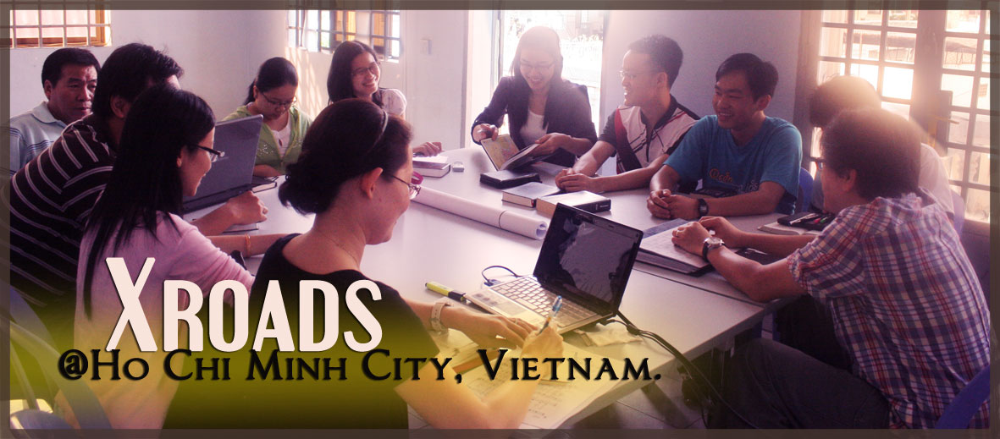
In our last update, we wrote about Xroads’ venture into Vietnam since end last year. We praise the Lord for His wisdom on how He brought together some young professionals from Ho Chi Minh city to adapt and establish Xroads ministry in a politically challenging environment. Please continue to pray for these leaders and volunteers that they will be bold in administering His words thus developing Christ centered disciples in Vietnam in spite of opposition from the government.
Last April 2011, the Lord has again assembled another group of young Indonesian professionals in San Jose, CA for similar purpose. After more than 4 years of relationship building and encouragement, and waiting, the Lord has convicted them thus to move them back to Jakarta to minister to Indonesian University students. We certainly need prayer, wisdom and financial support to develop the students in a Muslim country to be Christ centered disciples.

Family news
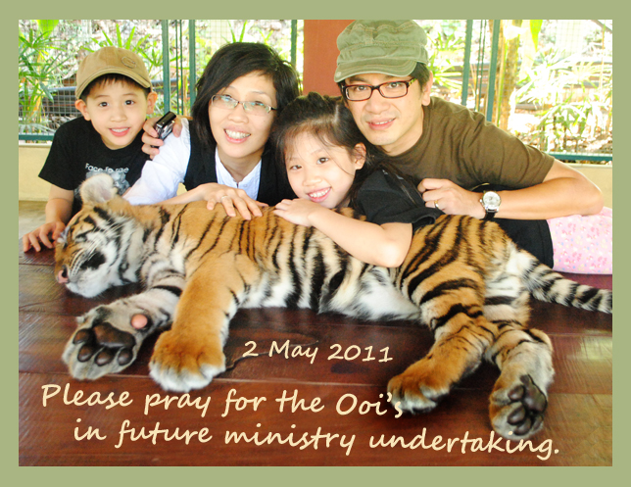
We had just gotten back from a two months travel ministry in US and Korea. Led by the Lord, we visited and spoke at difference churches, encouraging and teaching the word of God in mainly Korean and Chinese churches. We experienced much grace and saw how the trip is necessary to remind us that we are mere pilgrim on earth thus to set our hearts on Jesus.
Our children are growing well. Joey is now 9 yrs old, grade 3. We attended a homeschool conference at Chiangmai, Thailand and was so encouraged to hear that she is doing well academically. Joey is also quite developed emotionally. She is journaling to God often remembering that she can always confide in our beloving God. We pray that she will always end her journal in trusting God, with a heart of thanksgiving thus keeping a godly perspective of life in Christ.
Rohaam is turning 6 in a few days’ time. Rohaam reads bible a chapter each day. At the end of reading, he is to ‘highlight’ his favorite verse for that day thus explaining why he felt so. One of the recent passage/chapter of his reading touched our heart deeply was Genesis 12. His favorite verse was not what Moonjung and I had expected, not verse 1-4(common focus by minister). He picked verse 5 and being dumb-founded, we asked why. ‘I am glad he took his family along’ came the answer.
Please continue to remember us in your prayer. Moonjung and I have been wondering about marriage and His Great Commission. The God we believed created and ordained marriage. He is the same God that has commissioned us to undertake His Great Commission. The fact is that many have put their marriage at risk in the course of ministry. As we remain faithful to make disciples of all nations, please pray that we will grow deeper in our intimacy and our union with God. Please pray for His protection over our marriage, His grace and provision for our marriage as we press on in the end days.

Conclusion
One man came to Jesus and asked what to do to gain eternal life ( Luke 10 25-28). Jesus said, “What does it say to do? The man pressed Jesus for more, but Jesus wouldn’t give him any new information. Until he walked in obedience, he wasn’t going to get more. Obedience is certainly a signal to God that says, “God, I want to go the next step.” Please pray for the Xroads, for a genuine heart to want and desire obedience. Just like a mustard seed, please pray that the Xroads will allow God to orchestrate and to bring about Heaven on earth.

